**INDEX**

|  |  |  |
| --- | --- | --- |
| **Sr. No** | **Content** | **Pg. No** |
| 1 | Introduction |  |
| 2 | Recognition of Need |  |
| 3 | Problem Statement |  |
| 4 | Preliminary Investigation |  |
| 5 | System Analysis |  |
| 6 | Project Planning- Gantt Chart |  |
| 7 | Software Requirement Specification (SRS) |  |
| 8 | Modules |  |
| 9 | System Design |  |
| 12 | User Interface Designs |  |
| 13 | Testing |  |
| 14 | Limitations &Future Scope |  |
| 15 | Conclusion |  |
| 16 | Bibliography |  |

**INTRODUCTION**

*Glam Sphere, the ultimate destination for everything fashion!* This website is a step into a world where creativity knows no bounds, talent shines bright, and diversity is celebrated with every stitch and fabric.

Glam Sphere isn't just another fashion platform; it's an innovative digital hub meticulously crafted to celebrate the artistry and ingenuity of burgeoning fashion designers worldwide. Whether you're a seasoned industry professional, a passionate fashion enthusiast, or an aspiring designer eager to make your mark, you'll find a home here amidst our curated collections, exclusive behind-the-scenes insights, and interactive features.

The aim of this project is simple yet profound: to showcase the richness of fashion in all its forms while providing a platform for both established and emerging designers to shine. Explore our virtual runway of stunning collections, delve into the creative processes with behind-the-scenes glimpses, and immerse yourself in the ever-evolving world of fashion.

The users may join us as we embark on this exhilarating journey through the Glam Sphere, where style meets substance, and inspiration knows no bounds. Whether they're here to indulge their passion for fashion or seeking to expand their knowledge, they’re sure to find something to ignite their imagination and elevate their fashion experience.

**RECOGNITION OF NEED**

Recognition of need in software development refers to the identification of a problem or opportunity that can be addressed through the development of a software solution. It involves understanding the requirements and objectives of stakeholders, assessing feasibility, and determining the justification for initiating a software development project.

Following a thorough analysis of the requirements, the project's requirements consist of the following:

* + - * Users (designers and regular users) should be able to register and log in to the platform to access their respective dashboards.
* Designers and users should have the ability to manage their profiles, including personal information and preferences.
* Designers should be able to showcase their past work, including collections, individual designs, and collaborations.
* Designers should be able to post various tips for clothing and styling.
* Clients should be able to post their testimonials, ratings, and reviews.
* Users should be able to submit queries to the portal admin, who will respond to them.
* Users should be able to communicate with designers for custom designs, personalized tasks, and general inquiries.
* Users can get daily updates, fashion trends, behind-the-scenes insights, and industry news.
* Designers should be able to post job listings to hire employees.

**PROBLEM STATEMENT**

The fashion industry presents a dynamic landscape characterized by its diversity and intense competition. Fashion designers operate within this environment, continuously endeavouring to unveil their creativity, expand their reach to broader audiences, and maintain relevance in an ever-evolving market. Yet, amidst this fervent pursuit, traditional avenues available to designers for showcasing their work, engaging with consumers, and accessing resources for growth often fall short in terms of accessibility, inclusivity, and interactivity.

The existing platforms frequently fail to accommodate the diverse needs and aspirations of fashion designers, constraining their ability to thrive in the digital age. Challenges abound, ranging from limited exposure opportunities to fragmented channels of communication with potential clients and inadequate access to essential resources for professional development.

In response to these deficiencies, there arises a pressing need for an innovative solution—a comprehensive online platform meticulously tailored to the distinctive requirements of fashion designers in the contemporary era. This platform should serve as a beacon of inclusivity, offering a welcoming space where designers from all backgrounds can showcase their talents, connect with a global audience, and access invaluable resources for advancement.

By addressing these challenges head-on and leveraging the power of digital technology, such a platform has the potential to revolutionize the way fashion designers navigate the industry, empowering them to thrive in an increasingly competitive and dynamic landscape.

**PRELIMINARY INVESTIGATION**

Preliminary investigation refers to the initial phase of exploring a potential project or problem to determine its feasibility and gather essential information. It involves conducting a high-level examination of the problem statement, objectives, and requirements to ascertain whether a software solution is viable and warranted. The primary goal of preliminary investigation phase is to determine whether the proposed software project is worth pursuing and to lay the groundwork for more detailed analysis and planning in subsequent phases of the Software Development Life Cycle (SDLC).

As per my examination and analysis of various online fashion web portals, I have summed up my observations and conclusions below:

* Shortcomings in traditional avenues for designers to exhibit their work, connect with consumers, and access resources, particularly in terms of accessibility, comprehensiveness, and interactivity.
* Need for a compendious online platform tailored to address the challenges and opportunities faced by unrecognized fashion designers in the digital age.
* Proposed system identifies and addresses aforementioned needs by designing an online platform specifically for undiscovered designers providing them an opportunity to expand their reach and increase their audience.
* Key features of the system include user registration and login functionalities, the ability for designers to showcase their works, setup a communication channel between user and designer, information dissemination about fashion events and trends by the admin, user feedback mechanisms, creating employment opportunity to fashion interns and fashion influencers.

**SYSTEM ANALYSIS**

System analysis is the process of studying and understanding a system's components, functions, and objectives to develop a comprehensive understanding of its requirements and constraints. It involves gathering and analysing information about the system, identifying its strengths and weaknesses, and proposing solutions for improvement or development.

To sum up, system analysis aims to provide a clear understanding of the system's requirements, constraints, and objectives to inform the design and development of effective solutions that meet stakeholders' needs and expectations.

1. ***Business Needs:***

The proposed system is designed keeping in mind the demands of fashion aficionados and designers in present scenario. This innovative platform offers designers to display their creations after they have registered themselves on the portal. Similarly, users also have to register themselves in order to enjoy the complete facilities of the website. Designers are also given access to a forum where they may communicate with customers with different palettes. Keeping in mind about the nascent fashion students who are new in this field, they can gain important insights and tips on fashion. They can also catch up with latest trending fashion by staying updated with daily news feed. In addition, fashion interns may have a great opportunity to work with any designer that best suits their requirements and preferences. Reviews and comments are accepted from the users and in case of any query they are provided with an option to resolve their issue via support system of the portal.

1. ***Objectives:***

* Display the designer's collections, individual designs, and past work in a visually appealing and organized manner.
* Attract potential clients, including individual customers, retailers, stylists, and collaborators, who are interested in the designer's work.
* Provide customers with easy ways to connect with the designer and inquire regarding their respective works.
* Promote the designer's brand identity, aesthetic, and values through branding elements.
* Offer custom design services for clients who want personalized, made-to-measure clothing or accessories.

Overall, the objective of this portal is to create a compelling online presence that effectively showcases the designer's talent, attracts potential clients, drives sales, and builds a strong brand identity within the fashion industry.

1. ***Proposed System:***

The proposed system for the fashion designer web portal aims to create a comprehensive online platform that caters to the needs of fashion designers, aspiring designers, fashion enthusiasts, and industry professionals. All designers are required to register and log in to showcase their works. Users can also register and log in to communicate with them. The admin will post information about upcoming fashion events, trends, and styles. Users can provide feedback and reviews. They also have the option to hire any designer based on their needs and interests. Additionally, designers are provided with a forum to interact with customers that have different palettes.

1. ***Advantages:***

The proposed system can effectively navigate the complexities of the fashion industry and satisfy the basic requirements which were the basis of developing this system. A couple of intangible merits include:

* Users can easily browse through a number of fashion designers who suit their taste best.
* Users and designers can communicate with each other regarding any customizations or personalised tasks.
* Designers provide various tips for clothing and styling
* Users can give their valuable feedbacks and ask queries.
* It offers an opportunity for aspiring fashion students, graduates and interns to choose to work under their desired designer and get hands on experience in the field.

1. ***Feasibility Study:***

* A feasibility study is a crucial step in the early stages of planning for any project, venture, or initiative. It assesses the practicality and viability of an idea by examining various factors such as technical, economic, legal, and scheduling considerations.
* It involves defining the objectives, scope, and purpose of the project.
* Analysing market demand, trends, competitors, and potential customer segments.
* Identifying potential risks and uncertainties and developing strategies to mitigate them.

1. ***Operational feasibility:***

Operational feasibility assesses whether a proposed project aligns with the organization's capabilities, processes, and culture. It evaluates if the project can be effectively implemented and integrated into existing operations without causing significant disruptions. Factors considered include organizational readiness, resource availability, skills, training requirements, and potential resistance to change. This assessment ensures that the project can be successfully executed and sustained within the operational context of the organization.

1. ***Technical feasibility:***

Technical feasibility refers to the assessment of whether a proposed project can be successfully implemented using available technology and resources. It involves evaluating factors such as the availability of necessary hardware and software, compatibility with existing systems, scalability, security considerations, and the availability of technical expertise. A positive evaluation of technical feasibility indicates that the project can be realistically executed from a technical standpoint.

1. ***Economical feasibility:***

Economic feasibility evaluates the financial viability of a proposed project by analysing costs and benefits. It assesses whether the project's potential benefits outweigh its costs, considering factors such as initial investment, operational expenses, revenue generation, and potential return on investment. This analysis helps stakeholders determine if the project is financially sustainable and if it aligns with the organization's budgetary constraints and long-term objectives.

1. *Tools and Platform*

* *Back End Tools-*
  + *Python:*

Python is a high-level, interpreted programming language known for its simplicity and readability. It supports multiple programming paradigms, including procedural, object-oriented, and functional programming. Python's extensive standard library and third-party packages make it versatile, suitable for a wide range of applications such as web development, data analysis, artificial intelligence, scientific computing, and automation. Its clean syntax and easy learning curve make it a popular choice for both beginners and experienced developers.

* + *Django Framework:*

Django is a high-level Python web framework that simplifies web development by providing a clean and pragmatic design. It follows the "Don't Repeat Yourself" (DRY) principle and emphasizes rapid development and clean, pragmatic design. Django includes built-in features for handling tasks such as routing, database management, user authentication, and session handling, allowing developers to focus on building web applications rather than reinventing the wheel. It follows a model-view-controller (MVC) architectural pattern, with models representing the data, views handling user interaction, and templates rendering HTML content. Django's robust ecosystem, extensive documentation, and active community make it a popular choice for building scalable and maintainable web applications.

* + *SQLite:*

SQLite is a lightweight, serverless, self-contained, and open-source relational database management system (RDBMS) that operates without a separate server process. It is embedded directly into the application, making it ideal for applications that require a local database without the overhead of client-server architectures. SQLite databases are stored in a single cross-platform file, making them easy to manage and transport. Despite its lightweight nature, SQLite supports most of the SQL standard and is suitable for small to medium-sized databases, embedded systems, mobile applications, and prototyping.

* *Front End Tools*
  + *Html (Hypertext Markup Language):*

HTML is the standard markup language used to create the structure and content of webpages. It consists of a series of elements or tags that define the structure and semantics of the content, such as headings, paragraphs, images, links, and forms.

* + *CSS (Cascading Style Sheets):*

CSS is a stylesheet language used to style the appearance of HTML elements on a webpage. It allows web developers to control the layout, colours, fonts, spacing, and other visual aspects of webpages, ensuring a consistent and visually appealing user experience across different devices and browsers.

* + *JavaScript:*

JavaScript is a versatile programming language used to add interactivity, dynamic, behaviour, and functionality to webpages. It enables developers to create interactive

features such as animations, form validation, dynamic content updates, and user interface enhancements.

* + *Bootstrap:*

Bootstrap is a popular front-end framework for building responsive and mobile-first websites and web applications. It provides a collection of pre-designed HTML, CSS, and JavaScript components, such as navigation bars, buttons, forms, and grids, that developers can easily incorporate into their projects to streamline development and ensure consistency in design and layout.

* + *jQuery:*

jQuery is a fast lightweight, and feature-rich JavaScript library that simplifies the process of client-side scripting and DOM manipulation. It provides a wide range of functions and methods for tasks such as event handling, animation, AJAX requests, and DOM traversal, making it easier for developers to write concise and efficient JavaScript code.

* + *Ajax (Asynchronous JavaScript and XML):*

Ajax is a technique used to create dynamic and interactive web applications by making asynchronous HTTP requests to the server without reloading the entire page. It enables developers to update specific parts of a webpage dynamically in response to user actions, such as submitting a form, without interrupting the user’s experience. Ajax is commonly used in conjunction with JavaScript and server-side technologies like PHP, Python, or Node.js to build responsive and interactive web applications.

**PROJECT PLANNING**

Project planning is the initial phase of project management where the scope, objectives, tasks, resources, timelines, and deliverables are defined. It involves a systematic approach to outlining the steps required to achieve project goals. Key activities include defining project scope, identifying stakeholders, creating a work breakdown structure, estimating resources, developing a schedule, setting milestones, and creating a budget. Effective project planning ensures clarity, alignment, and organization, laying the foundation for successful project execution and monitoring.

***Project Schedule Plan:***

***Gantt Chart***

A Gantt chart is a popular project management tool used to visualize and track the progress of tasks or activities over time. It displays project activities along a horizontal timeline, with each activity represented by a bar. The length of each bar corresponds to the duration of the activity, while its position along the timeline indicates its start end dates.

SOFTWARE REQUIREMENT SPECIFICATION(SRS)

* + - 1. ***Purpose:***
* Fashion websites serve as powerful marketing tools for brands seeking to connect with consumers in the digital age.
* The portal aims in empowering emerging talent.
* It fosters collaboration, knowledge-sharing, and mentorship opportunities by connecting aspiring designers with industry professionals.
* The portal bridges the gap between education and industry by providing practical insights, resources, internships, apprenticeships, and mentorship programs.
* It promotes diversity and inclusion within the fashion industry.
* Lastly, the scope of this project is wider and tends to drive positive change and innovation in the industry.
  + - 1. ***Formatting Guidelines:***

1. ***Text Formatting***
   * **Font:** Garamond
   * **Font Size:**
     + **For major headings:** 14 pt
     + **For subheadings:** 12 pt
     + **For content:** 12 pt

* **Text Alignment:** Justified
* **Headings:** Bold, Capitalised, Underlined, Center
* **Subheadings:** Bold, Sentence case, Underlined
* **Line Spacing:** 1.5 lines

1. ***Lists***

* **Numbered Lists:** Use Arabic numerals (1., 2., 3.) for numbered lists and Roman numerals (i., ii., iii.) or (1.1,1.2,1.3,) for nested list
* **Bullet Points:** Use Disc (•) for bulleted lists and circle (ο) for nested bullet list.

1. ***Tables:***

* **Table Format:** Use grid lines with headers bolded.
* **Table captions:** Place captions below the table
  + - 1. ***Intended Audience and Reading suggestion:***
* Fashion Designers: Professional fashion designers who will use the platform to showcase their work and interact with potential clients.
* Aspiring Designers: Individuals aspiring to become fashion designers who may seek inspiration, guidance, or networking opportunities through the platform.
* Fashion Enthusiasts: Individuals with a keen interest in fashion who may use the platform to stay updated on fashion events, trends, and styles.
* Industry Professionals: Professionals working in the fashion industry, such as stylists, photographers, marketers, etc., who may benefit from networking and collaboration opportunities on the platform.
  + - 1. ***Project Scope:***
* Creating a visually appealing and organized platform to showcase the designer's collections, individual designs, and past work. This involves designing user-friendly interfaces and galleries to present the content effectively.
* Implementing features that allow potential clients, including individual customers, retailers, stylists, and collaborators, to connect with the designer easily. This may include contact forms, messaging systems, or other communication tools.
* Promoting the designer's brand identity, aesthetic, and values through branding elements. This may involve incorporating the designer's logo, colour schemes, and brand messaging throughout the website.
* Providing custom design services for clients who want personalized, made-to-measure clothing or accessories. This may involve implementing customization options, order forms, and payment processing systems.
* Overall, the project scope involves designing and developing a comprehensive online platform that effectively showcases the designer's talent, attracts potential clients, drives sales, and builds a strong brand identity within the fashion industry. It includes elements related to website design, user experience, branding, communication, and e-commerce functionality to achieve the stated objectives.

|  |  |
| --- | --- |
| Components | Annotation |
| Mandatory | M |
| Discretionary | D |
| Contingent | C |

* + - 1. ***Functional Requirements:***

|  |  |  |  |
| --- | --- | --- | --- |
| Sr. No | Req. No. | Priority | Requirements Description |
| 1 | R1 | M | SignUp/SignIn by all types of users |
| 2 | R2 | D | View/Edit profile by all types of users |
| 3 | R3 | D | Users can provide their valuable feedbacks |
| 4 | R4 | C | Users can browse designers either by logging in or from the portal directly |
| 5 | R5 | D | Delete/Update/View account of all kind of users by Admin |
| 6 | R6 | D | Users can post their query on the portal |
| 7 | R7 | C | Users can communicate with the designers |
| 8 | R8 | D | Designers can post tips and tricks regarding clothing and styling |
| 9 | R8 | D | Admin can post daily news and events |
| 10 | R10 | D | Designers may post their works and achievements |
| 11 | R11 | D | Designers may post open job vacancies |

**Table 1. Priority order of functions to be performed**

* + - 1. ***Non-Functional Requirements:***
* Only registered users can do login and perform their tasks.
* Secure access of confidential data SSL can be used.
* 24*7 availability.
* Better component design to get better performance at peak time
* Flexible service-based architecture will be highly desirable for future extension.
  + - 1. ***Output Requirements:***
* All the information generated by the application is presented on the Django Html templates when needed.
* The output screens are designed using Django technology to show the information in attractive manner.
* Web pages fulfil the output standards by showcasing the output in an appealing manner.

1. ***Other Non-Functional Requirements:***
   1. *Performance Requirements:*

The speed of the network connection affects performance. A highly congested internet network will naturally reduce the responsiveness of servers. Our website may take a while to load in this situation. Other than that, this website doesn't have any internal complexity.

* 1. *Safety Requirements:*

This product is not too expensive because it is built on the Agile methodology and SDLC. The entire product has already been developed during the first cycle of development, so minor adjustments simply need to be done upon request from the client.

* 1. *Security Requirements:*

Reliability is increased via administrator’s internal management. Its dependability is further guaranteed by secure administration and administrator login at a separate URL.

* 1. *Scalability Requirements:*

Portal should be scalable so that it can be scaled up and down as per requirements and traffic fluctuations. Since we are developing the web portal using Django framework, it provides several features and practices that can aid in scaling the portal, such as efficient ORM, MVC architecture, horizontal scaling, caching mechanisms, etc.

* 1. *Software Quality Attribute:*
* Reliability: The system shall be reliable, with a low probability of failure, and shall accurately perform its intended functions under normal and abnormal conditions.
* Performance: The system shall meet specified performance criteria, including response time, throughput, and resource utilization, under expected load conditions.
* Scalability: The system shall be scalable, able to handle increased loads, users, or data volumes by adding resources or components without significant degradation in performance.
* Availability: The system shall have high availability, ensuring that it is accessible and operational for users according to agreed-upon service level agreements (SLAs).
* Security: The system shall be secure, protecting data, resources, and users' privacy through measures such as authentication, authorization, encryption, and access control.
* Usability: The system shall be user-friendly, with an intuitive interface and clear navigation, allowing users to accomplish tasks efficiently and effectively with minimal training or assistance.
* Maintainability: The system shall be maintainable, with well-structured, modular code that is easy to understand, modify, and extend, facilitating ongoing maintenance and updates.
* Portability: The system shall be portable, able to run on different hardware platforms, operating systems, and environments without significant modifications or dependencies.
* Interoperability: The system shall be interoperable, able to communicate and exchange data with other systems or components through standard interfaces, protocols, and formats.
* Compliance: The system shall comply with relevant standards, regulations, and industry best practices, ensuring legal, regulatory, and ethical compliance in its design, development, and operation.

1. *Product Perspective:*

* The Glam Sphere web portal is a web-based application that typically revolves around showcasing the designer’s work, connecting with clients, and promoting their brand.
* The system will feature a web-based graphical user interface (GUI) accessible via any updated browser.
* The system is designed for fashion enthusiasts, industry professionals, and administrators. Users are expected to have basic computer literacy and internet access.
* The system will interact with standard hardware components such as servers, routers, and storage devices.

1. *Product Features:*

* Users and Designers are expected to create their respective accounts in order to enjoy all the features of the system.
* End user should be able to post their queries.
* User should be able to communicate with the designer
* Designer can post their past works and experiences
* Admin can post trending news and ongoing/scheduled events.

1. *User Classes and Characteristics:*

The system has three roles:

* **Admin:** Admin will be able to see all types of users and perform authentication tasks.
* **Designer**: Designer can register themselves, showcase their past work, collections and post various tips for clothing and styling, and offer jobs.
* **End User:** User can also register themselves and browse through various designers who suit their palette and communicate with them.

1. *Resources (Hardware & Software):*

Hardware Requirements:

|  |  |
| --- | --- |
| Client Side: | A digital device with high internet connection to access the website |
| Developer side: |  |
| Processor | Core i3 or above |
| RAM | 4GB |
| HDD | 512GB |
| Display | High Resolution screen |
| Others | Internet connection |

Software Requirements:

|  |  |
| --- | --- |
| Client Side: |  |
| Web Browser | Any updated browser |
| Developer side: |  |
| Browser | Any updated browser |
| IDE | Visual Studio Code |
| Language | Python |
| Framework | Django |
| Database | SQLite |

1. *Assumption and Dependencies:*

* It is assumed that users will have access to internet-enabled devices to access the system.
* The project may face delays due to unforeseen technical issues or changes in regulatory requirements.

MODULES

1. Registration and Login: This module allows users (both designers and regular users) to create accounts on the platform by registering with their relevant information. Once registered, they can log in using their credentials to access their personalized dashboard, where they can manage their account settings, view past activity, etc.
2. Profile Management: This module enables designers and users to manage their profiles. They can update personal information, upload profile pictures, add descriptions about themselves or their brands, and manage other details that showcase their identity on the platform.
3. Work Collections Management: Designers utilize this module to showcase their previous work. They can organize their work into collections, display individual designs, and highlight collaborations with other designers or brands. This feature serves as a portfolio for designers to exhibit their expertise and style to potential clients.
4. Tips and Tricks Management: Designers can share valuable insights, tips, and tricks related to clothing, styling, fashion trends, and industry practices through this module. It serves as a knowledge-sharing platform where designers can engage with their audience by offering valuable advice and expertise.
5. Testimonials Management: Clients can provide feedback, ratings, and reviews about their experiences with designers or services offered on the platform. This module allows users to share their testimonials, helping to build trust and credibility for designers and the platform as a whole.
6. Query Management: Users can submit queries or questions through the platform, and administrators will respond to them. This module facilitates communication between users and administrators, ensuring that any concerns or inquiries are addressed promptly and effectively.
7. Administration: Administrators have access to this module, which provides them with the necessary tools to manage the platform efficiently. They can view and manage user accounts, moderate content, address user queries, and perform other administrative tasks to ensure smooth operation and compliance with policies.
8. Online Communication: This module facilitates communication between users (clients) and designers for custom design requests, personalized tasks, and general inquiries. It may include features such as messaging, chat, or video calls to enable direct and real-time interaction between users and designers.
9. News and Upcoming Events Management: Administrators can use this module to share updates, fashion trends, behind-the-scenes insights, and news related to the fashion industry. It keeps users informed about the latest developments and events happening within the fashion community.
10. Job Management: Designers can post job openings on the platform to hire employees or collaborators. This module allows designers to advertise job opportunities, specify requirements, and manage applications from potential candidates. It serves as a platform for connecting designers with talented individuals seeking employment opportunities in the fashion industry.

*Modules covered by me*

* Work Collections Management
* Testimonials Management
* Administration
* On Line Communication
* Job Management

SYSTEM DESIGN

* + - 1. ***Software Process Model:***

**Agile Development Model:**

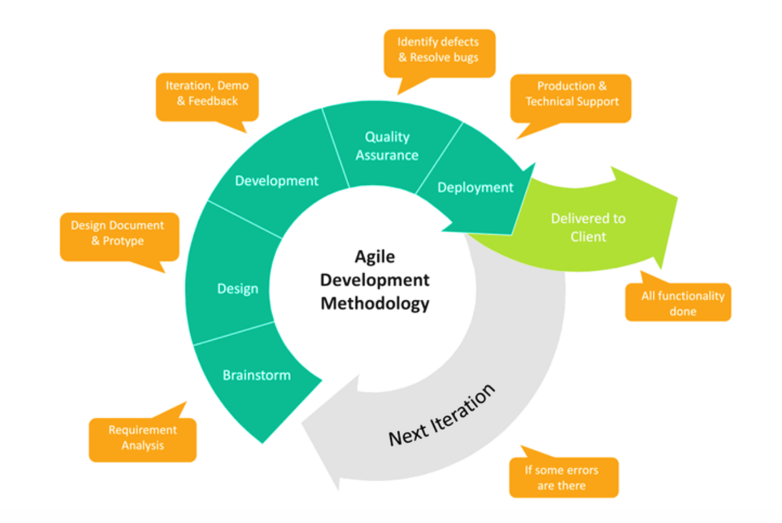

In Agile development, the process is often organized into phases or stages that correspond to different aspects of the software development lifecycle. Agile approaches emphasize flexibility and adaptability in development. Iterative development schedules are used instead of a rigid schedule which takes a great deal of time and is difficult to manage. The following phases provide a structured framework for organizing work and collaboration:

1. ***Brainstorm:***

* In the brainstorm phase, the project team collaborates to generate ideas, identify goals, and define the scope of the project.
* Stakeholders, including product owners, developers, designers, and end-users, participate in brainstorming sessions to explore requirements, user needs, and potential solutions.
* Techniques such as user story mapping, mind mapping, and ideation workshops may be used to facilitate brainstorming and idea generation.

1. ***Design****:*

* In the design phase, the project team translates the ideas generated during brainstorming into tangible design concepts and prototypes.
* User experience (UX) designers create wireframes, mockups, and prototypes to visualize the user interface (UI) and user interactions.
* Architects and developers collaborate to design the system architecture, define technical components, and establish development guidelines.
* Design reviews and feedback sessions are conducted to gather input from stakeholders and validate design decisions.

1. ***Development:***

* The development phase involves implementing the design concepts and building the software incrementally.
* Development work is organized into short iterations or sprints, typically lasting 1-4 weeks, with each iteration delivering a potentially shippable product increment.
* Developers write code, conduct unit tests, and integrate their work into the main codebase frequently, following Agile development practices such as test-driven development (TDD) and continuous integration (CI).
* Collaboration and communication within the development team are essential to address challenges, clarify requirements, and ensure alignment with project goals.

1. ***Quality Assurance:***

* Quality assurance (QA) activities run concurrently with development throughout the iteration.
* Testers create and execute test cases to verify the functionality, performance, and security of the software.
* Automated testing frameworks and tools are used to expedite testing and ensure consistent coverage across different platforms and environments.
* Defects and issues discovered during testing are logged, prioritized, and addressed promptly by the development team to maintain software quality.

1. ***Deployment:***

* The deployment phase involves preparing the software for release and deploying it to production or staging environments.
* Deployment processes may vary depending on the project's infrastructure, deployment strategy, and release cadence.
* Automated deployment tools and scripts are often used to streamline the deployment process and minimize manual errors.
* Continuous delivery and continuous deployment practices enable frequent and reliable releases, with automated pipelines facilitating the deployment of new features and updates.

1. ***Launch:***

* The launch phase marks the official release of the software to end-users or customers.
* Marketing and communication efforts are coordinated to announce the launch, generate excitement, and drive adoption of the new software.
* Feedback channels are established to gather user feedback, monitor performance, and address any issues or concerns that may arise post-launch.
* Iterative improvements and enhancements continue post-launch based on user feedback, usage metrics, and evolving business needs.

These phases provide a structured framework for organizing Agile development activities while allowing for flexibility, iteration, and continuous improvement throughout the software development lifecycle. Collaboration, communication, and feedback play crucial roles in each phase, enabling the project team to deliver high-quality software that meets user needs and business objectives effectively.

* + - 1. ***System Designing Approaches:***

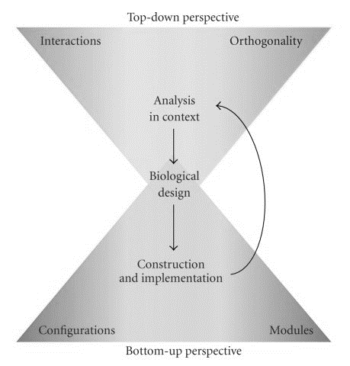

* + - * 1. ***Top-Down Approach:***

The **top-down** approach is a problem-solving strategy that starts with broad goals or objectives and progressively decomposes them into smaller, more manageable components. Beginning with an overarching view, it breaks down complex tasks into hierarchical levels of detail, facilitating planning and organization. This method fosters clarity and alignment with high-level objectives while allowing for flexibility and iteration as implementation progresses. It provides a structured framework for addressing complex problems, guiding the development process from a holistic perspective to increasingly granular levels of detail. The top-down approach encourages systematic decomposition and refinement, ensuring effective problem-solving and project management.

* + - * 1. ***Bottom-Up Approach:***

The **bottom-up** approach is a problem-solving or development strategy that starts with individual components or tasks and builds upward to form a complete solution or system. It begins with identifying and developing small, granular elements, which are then integrated and combined to create larger, more complex structures. This method emphasizes starting from the ground level and incrementally building upon existing components, allowing for flexibility and adaptation as the solution evolves. The bottom-up approach promotes thorough understanding of individual components and fosters organic growth, enabling efficient problem-solving and the creation of scalable, modular systems.

* + - 1. *HIGH LEVEL DESIGN*
  1. *UML Diagrams:*

Unified Modelling Language (UML) diagrams are visual representations used to illustrate the structure, behaviour, and interactions of a system or software application. They provide a standardized way to communicate complex systems and processes, making it easier for stakeholders to understand and analyse the system's architecture and design. UML diagrams come in various types, such as class diagrams, use case diagrams, sequence diagrams, activity diagrams, state machine diagrams, component diagrams, and deployment diagrams. Each type serves a specific purpose and helps document different aspects of the system, facilitating communication, analysis, and design in software development and system engineering.

* + 1. ***Use Case Diagram:***

A Use Case Diagram is a visual representation in Unified Modelling Language (UML) that illustrates the interactions between actors (users, external systems, or roles) and a system or software application. It showcases the various use cases or functionalities provided by the system from the perspective of its users. Use case Diagrams are important because:

* Requirement Analysis: Use Case Diagrams help in eliciting, organizing, and documenting system requirements by capturing user goals and system functionalities.
* Communication: They serve as a communication tool between stakeholders, including developers, designers, project managers, and end-users, enabling a shared understanding of the system's functionality.
* Scope Definition: Use Case Diagrams define the boundaries of the system by identifying the actors and their interactions with the system, thereby clarifying its scope.
* System Design: They provide a high-level overview of the system's behaviour and functionality, aiding in system design and architecture decisions.
* Validation: Use Case Diagrams facilitate validation of system requirements with stakeholders, ensuring that the system meets the needs of its users.
* Blueprint for Testing: They serve as a blueprint for test case development, helping in the identification of test scenarios and ensuring comprehensive test coverage.
* Iterative Development: Use Case Diagrams support iterative development by providing a basis for incremental refinement and validation of system requirements throughout the development lifecycle.

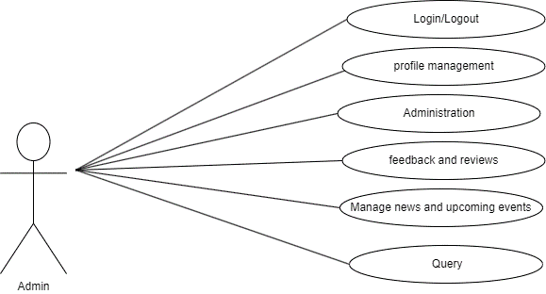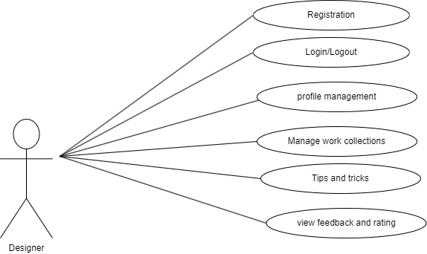

(b)

(a)

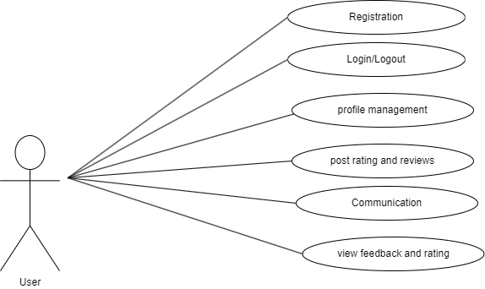

(c)

Figure 1. Use Case diagram

* + 1. ***Entity-Relationship Model (ER- Model):***

An Entity-Relationship (ER) diagram is a visual representation used in database design to illustrate the structure of a database. It depicts entities (objects or concepts), their attributes (properties or characteristics), and the relationships between them.

ER diagrams serve several purposes in database design:

* They provide a visual representation of the database schema, making it easier to understand and communicate the structure of the database.
* They help in identifying entities, attributes, and relationships that need to be represented in the database.
* They assist in designing and normalizing the database schema to eliminate redundancy and improve data integrity.
* They serve as documentation for the database schema, facilitating database maintenance, troubleshooting, and future development.

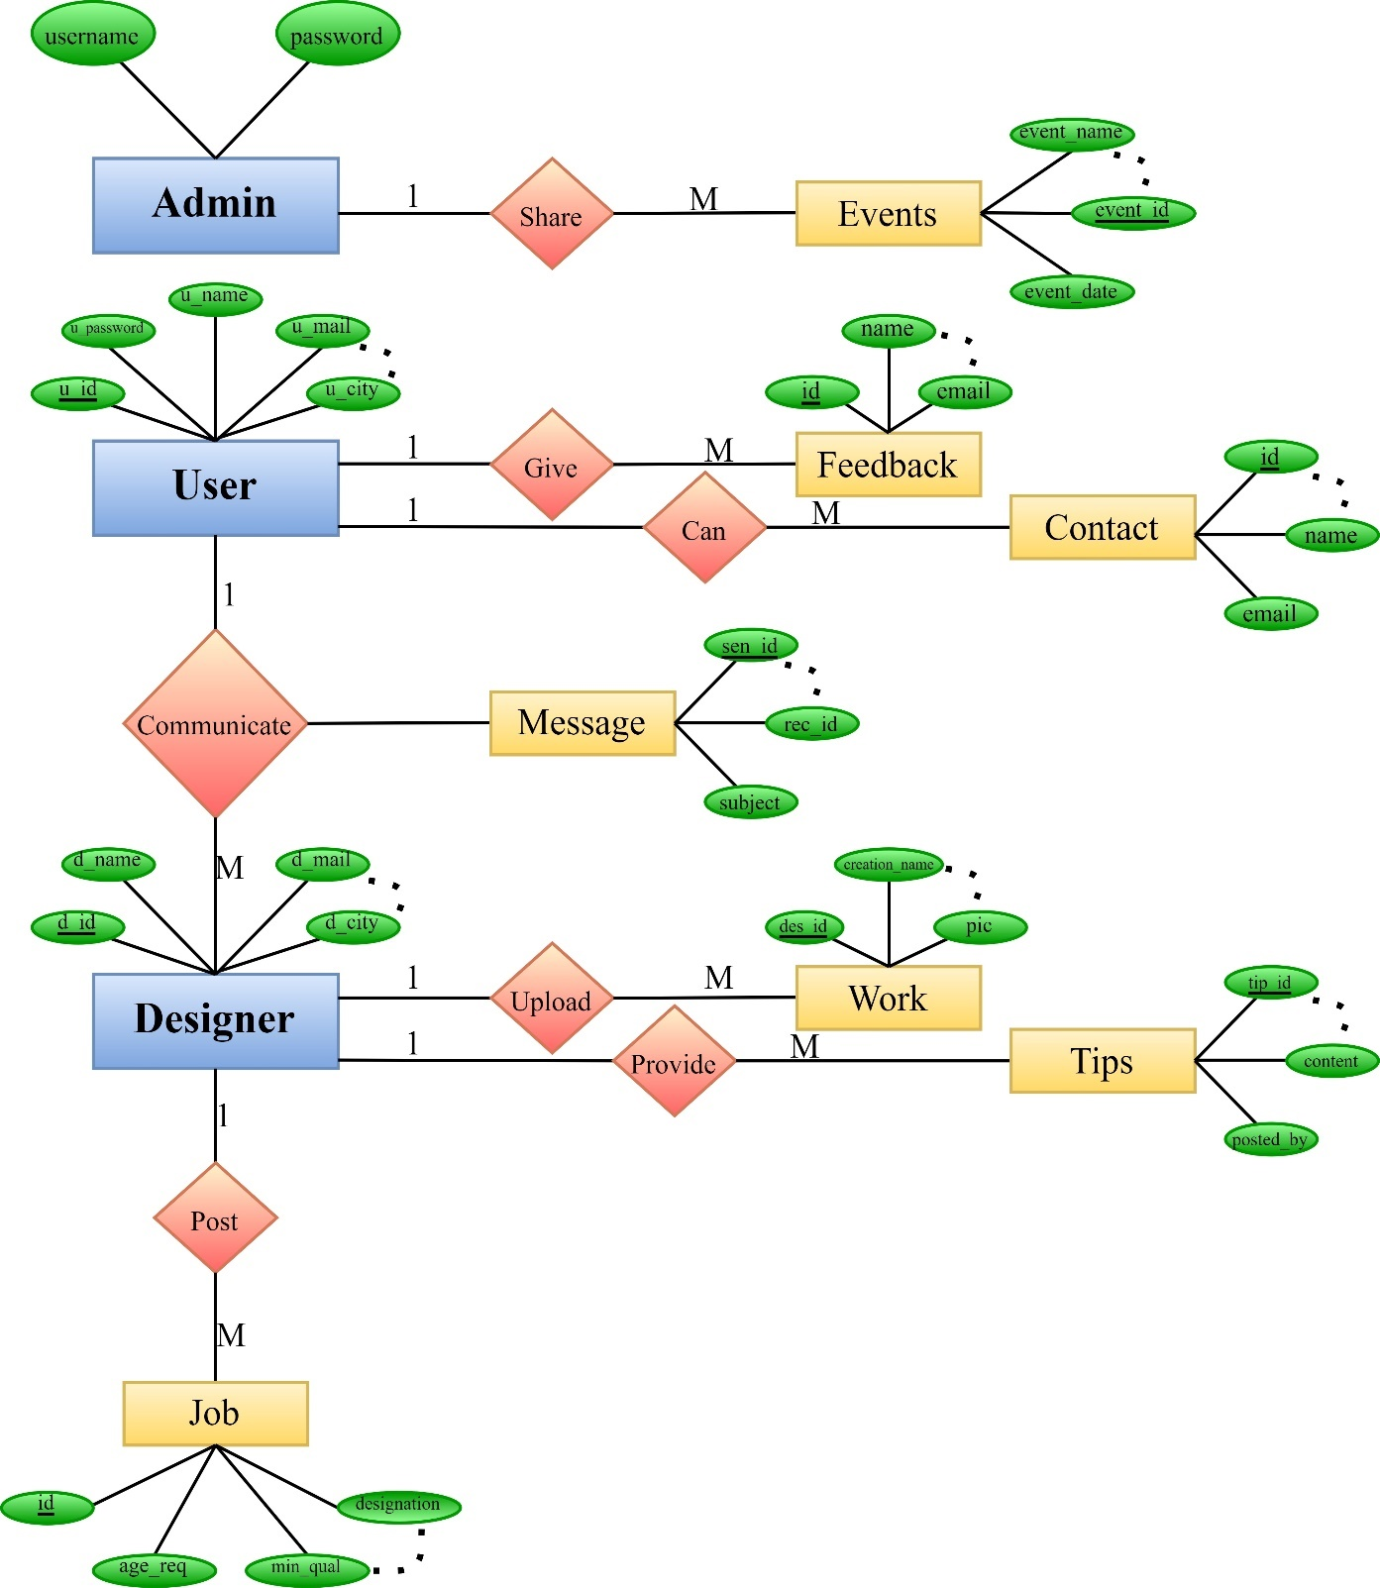

Figure 2. E-R Diagram

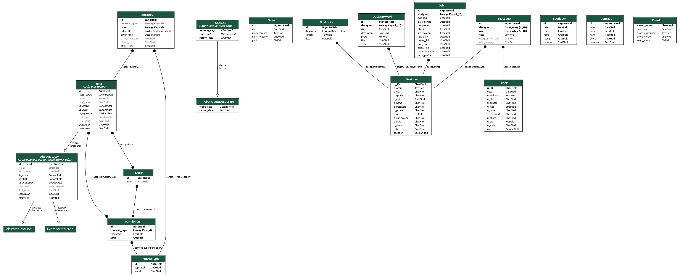



Figure 3. Model based ER

* + 1. ***Data Flow Diagram (DFD):***

A Data Flow Diagram (DFD) is a graphical representation that depicts the flow of data within a system or process. It consists of various components that illustrate how data moves through the system, including processes, data stores, data flows, and external entities. DFDs are commonly used in system analysis and design to visualize the data flow and understand the system's functionality. DFDs are used for several purposes in system, analysis and design:

* They provide a visual representation of the system’s data flow and processiing logic, making it easier to understand and analyze the system’s behaviour.
* They help in indetifying the inputs, outputs, and processes involved in the system, facilitating requirements gathering and analysis.
* They assist in identifying data redundancies, inefficiencies, and bottlenecks within the system, enabling optimization and improvement.
* They serve as documentation for the system’s design, aiding in communication among stakeholders and providing a basis for system implementation and testing.

The zero level (context level) and first level DFDs are explained below:

* **Zero Level DFD (Context Level DFD):**
* The zero level DFD provides an overview of the entire system, showing how it interacts with external entities.
* It represents the system as a single process (usually labeled as "System") surrounded by external entities.
* Data flows between the system and external entities, representing inputs and outputs to/from the system.
* The zero level DFD helps to understand the system's scope and boundaries without delving into its internal processes.

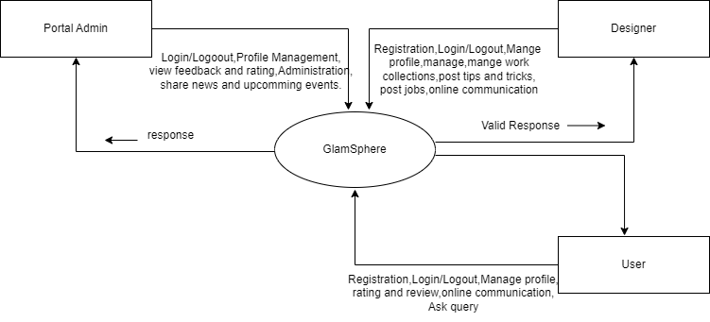

Figure 4. Context Level DFD

* **First Level DFD:**
* The first level DFD expands on the processes depicted in the zero level DFD by breaking them down into more detailed subprocesses.
* It decomposes the system into multiple processes, each representing a specific function or activity.
* Data flows between processes and data stores, illustrating how data is processed and stored within the system.
* External entities interact with specific processes, showing their involvement in the system's functionality.
* The first level DFD provides a more detailed view of the system's internal workings, helping to identify specific processes and data flows within the system.

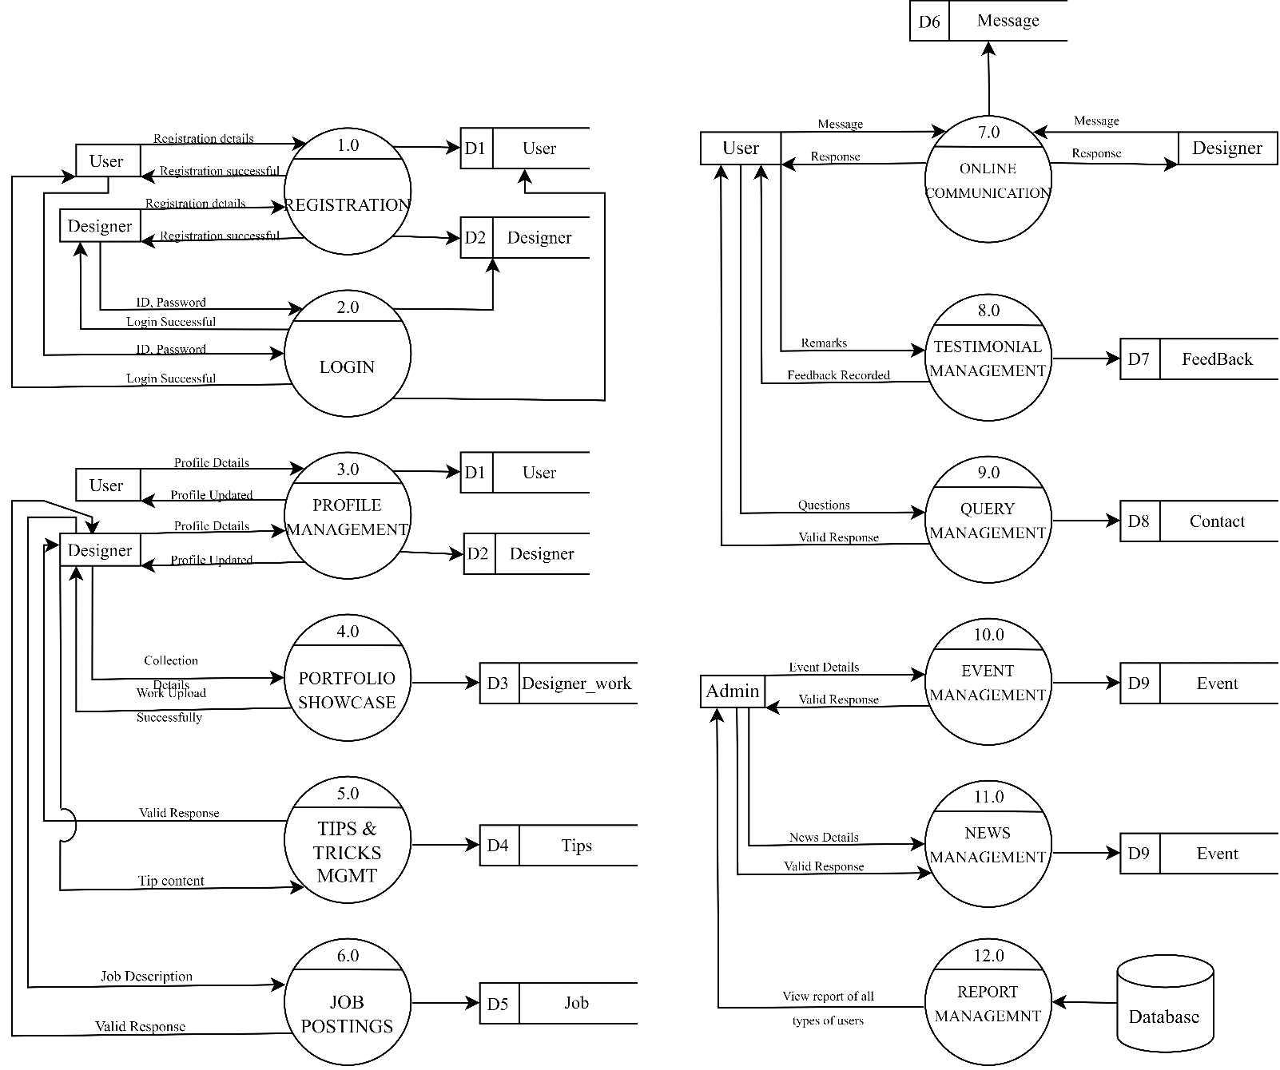

Figure 5. First-level dfd

1. ***LOW LEVEL DESIGN***
   1. ***DATABASE DESIGN:***

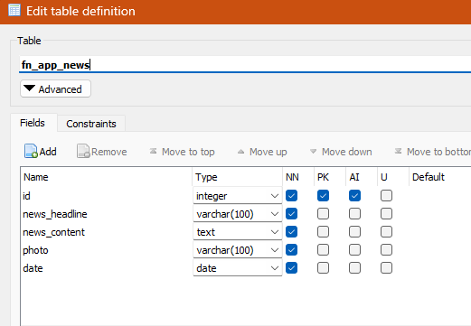 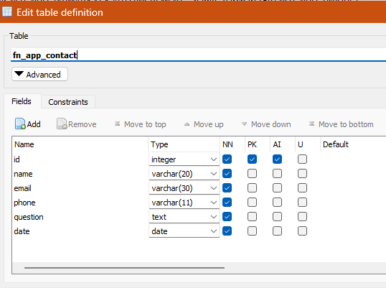

(b)

(a)

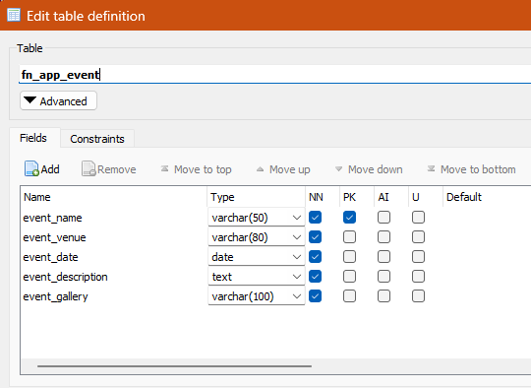 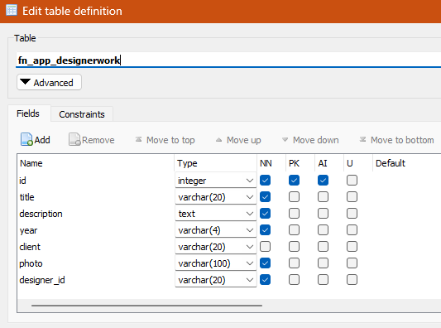

(d)

(c)

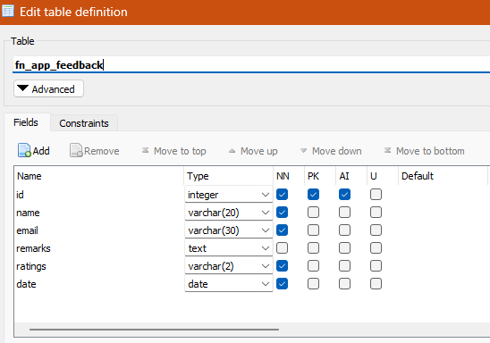 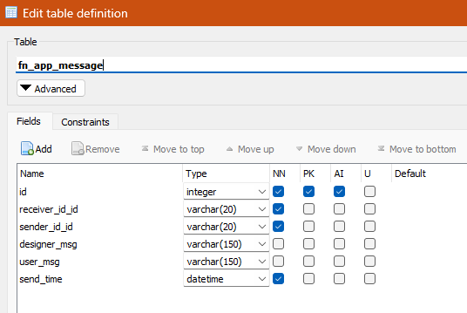

(f)

(e)

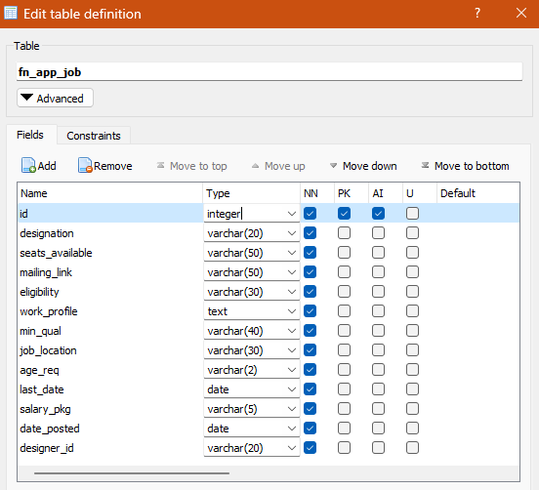 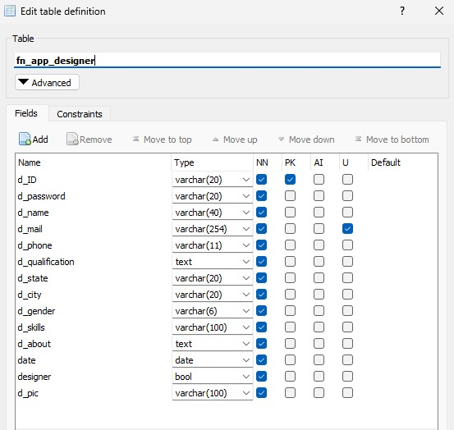

(g)

(h)

 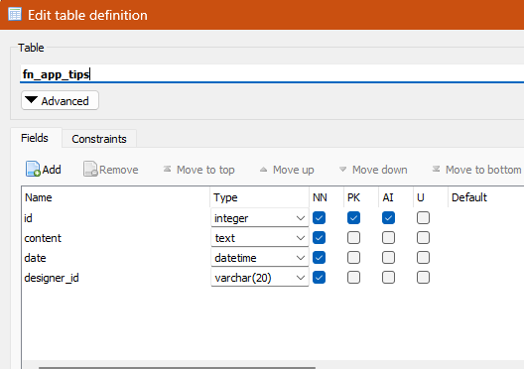

(j)

(i)

Figure 6. Database structure

1. ***User Interface Design***

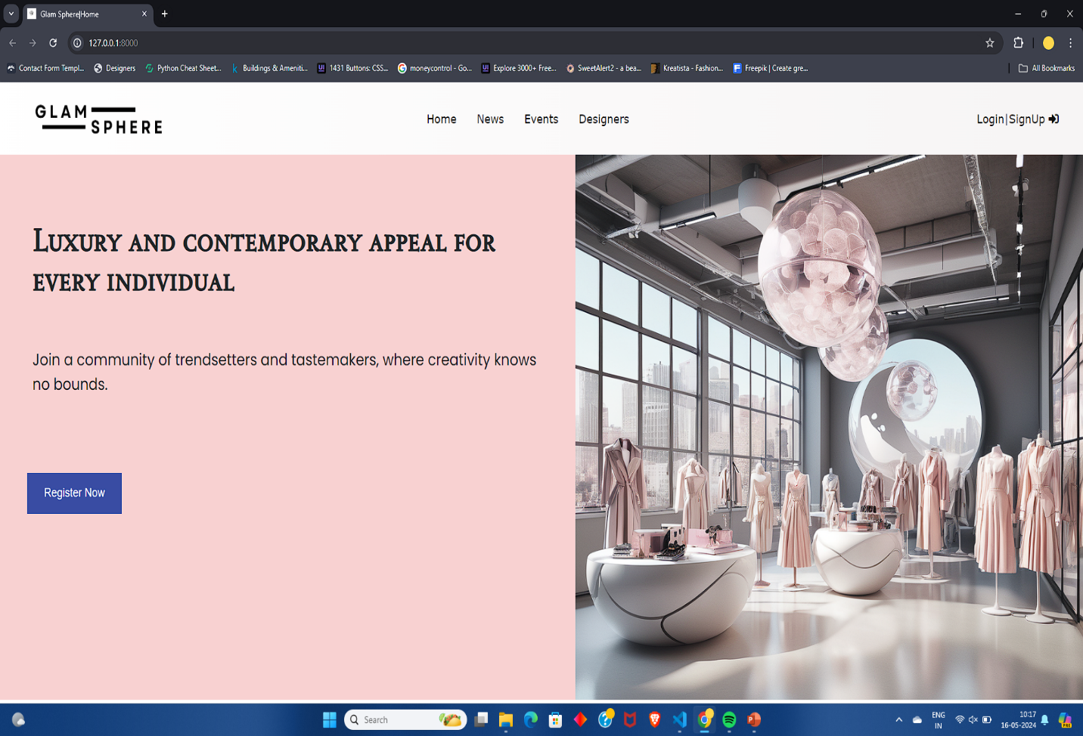

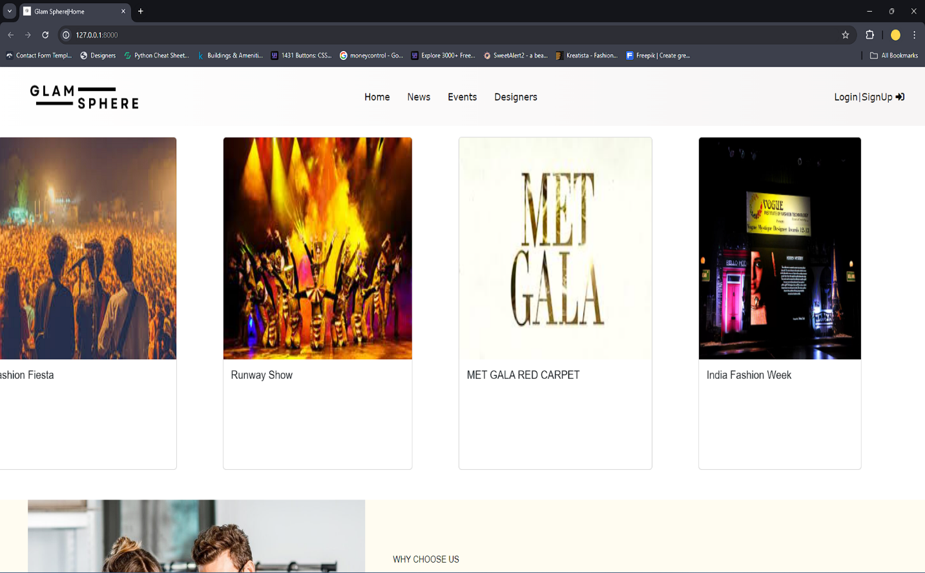

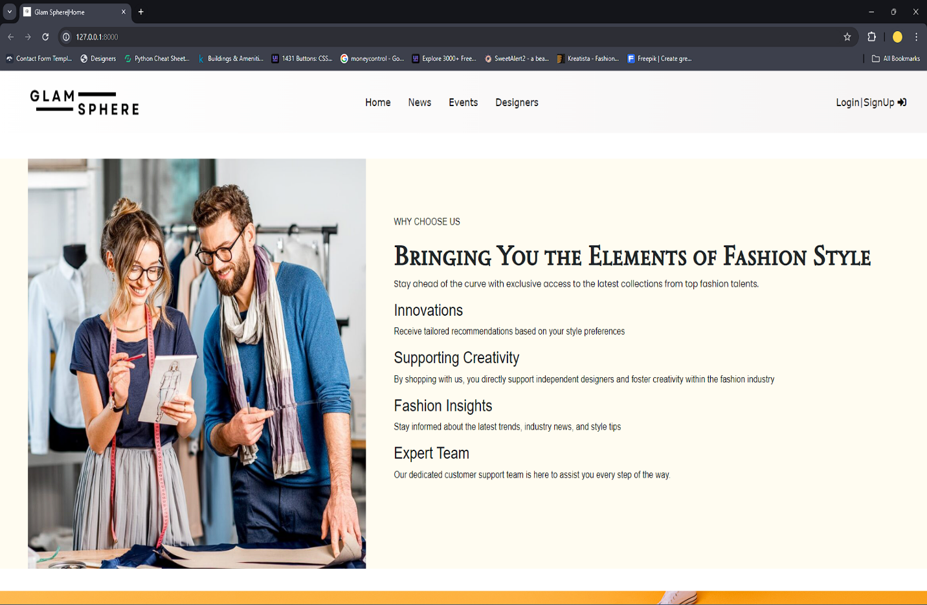

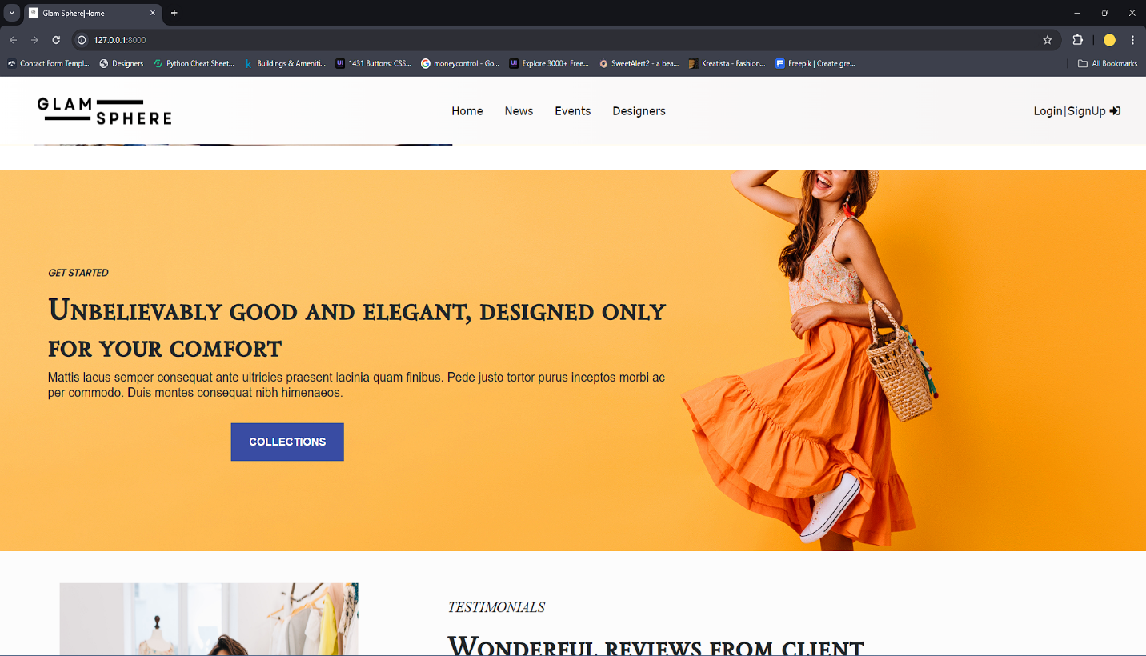

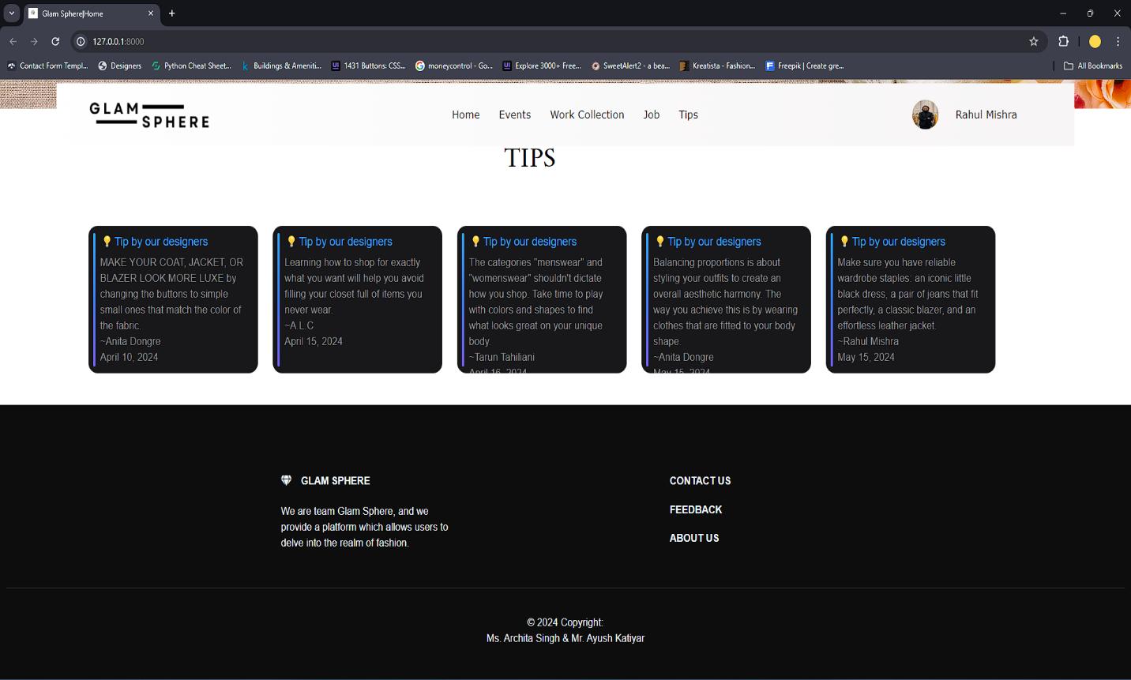

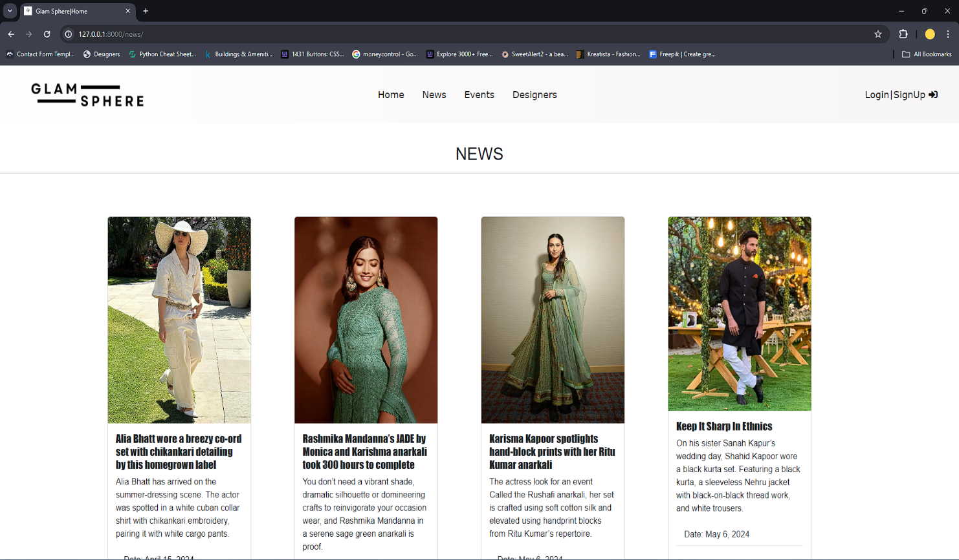

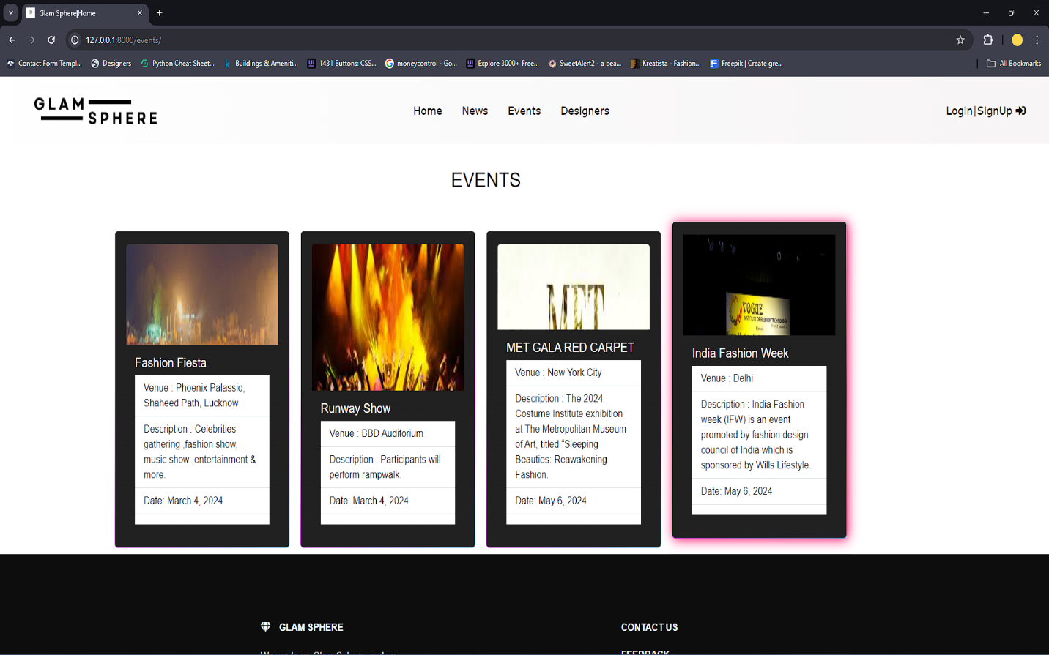

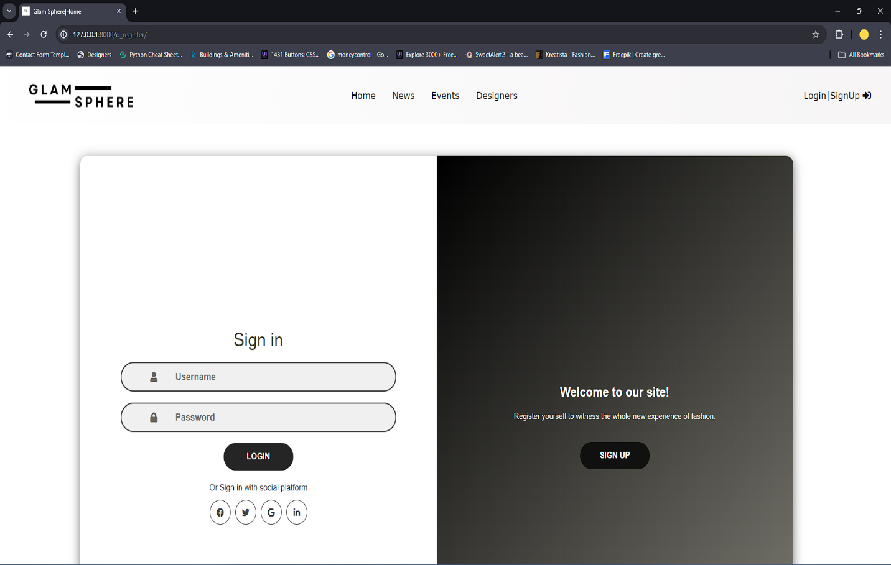

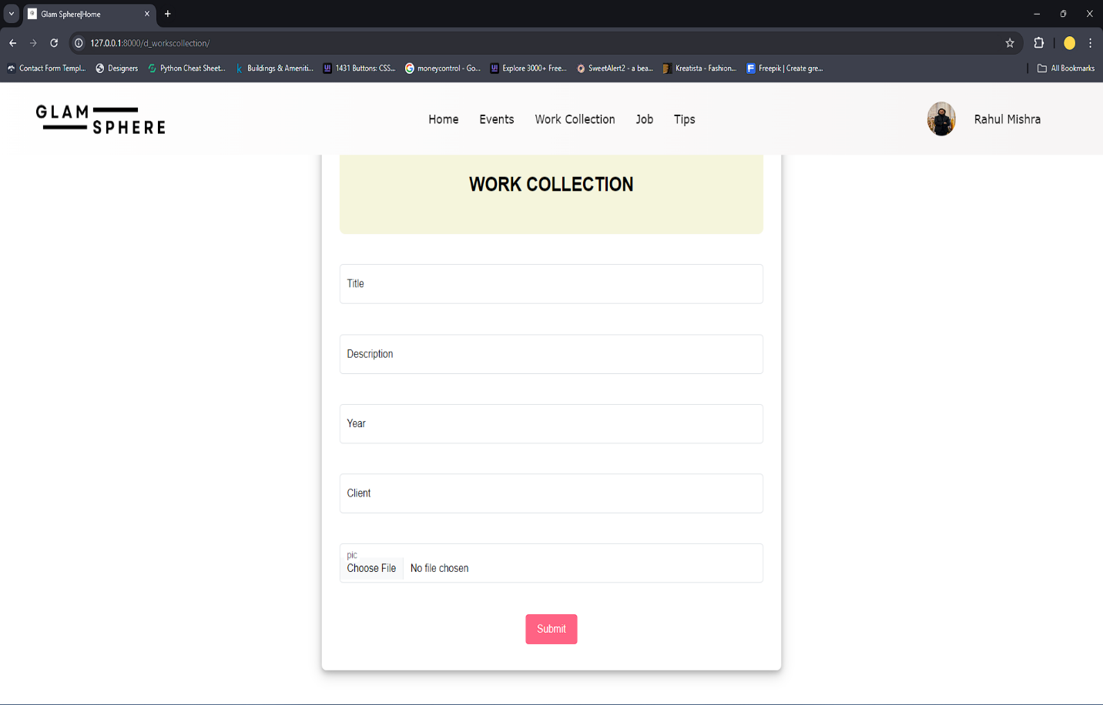

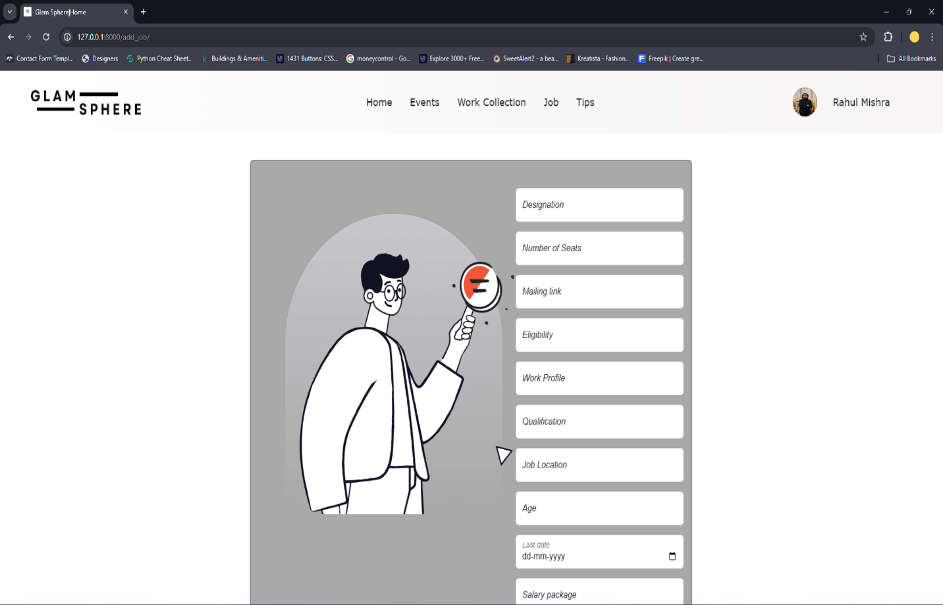

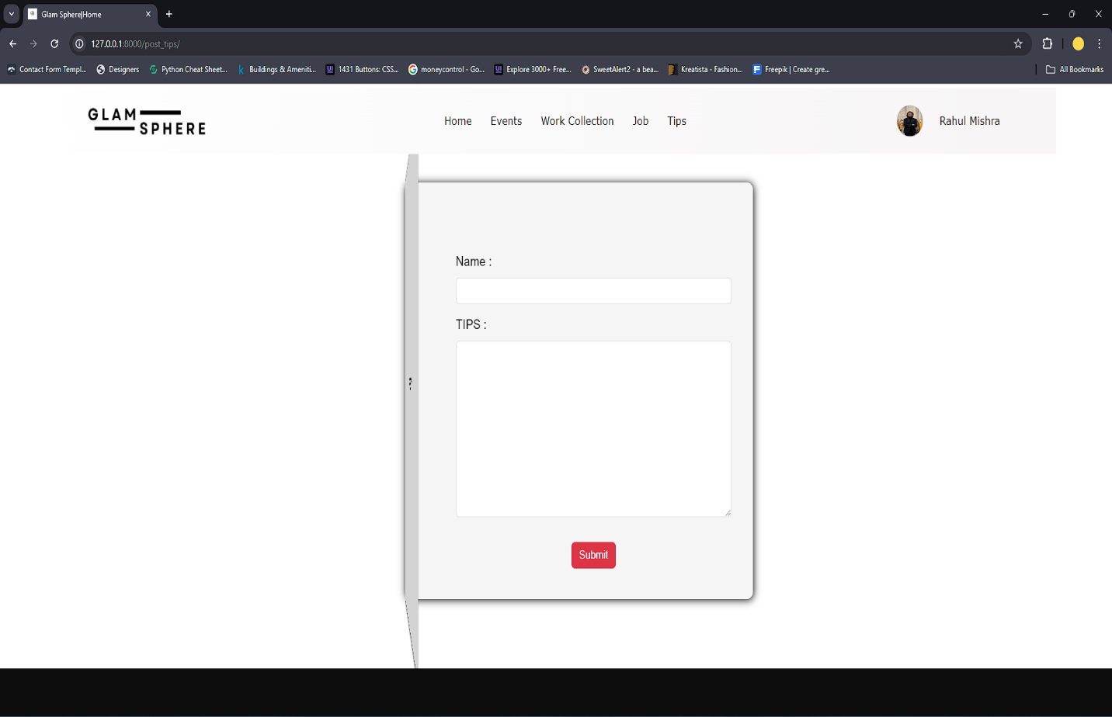

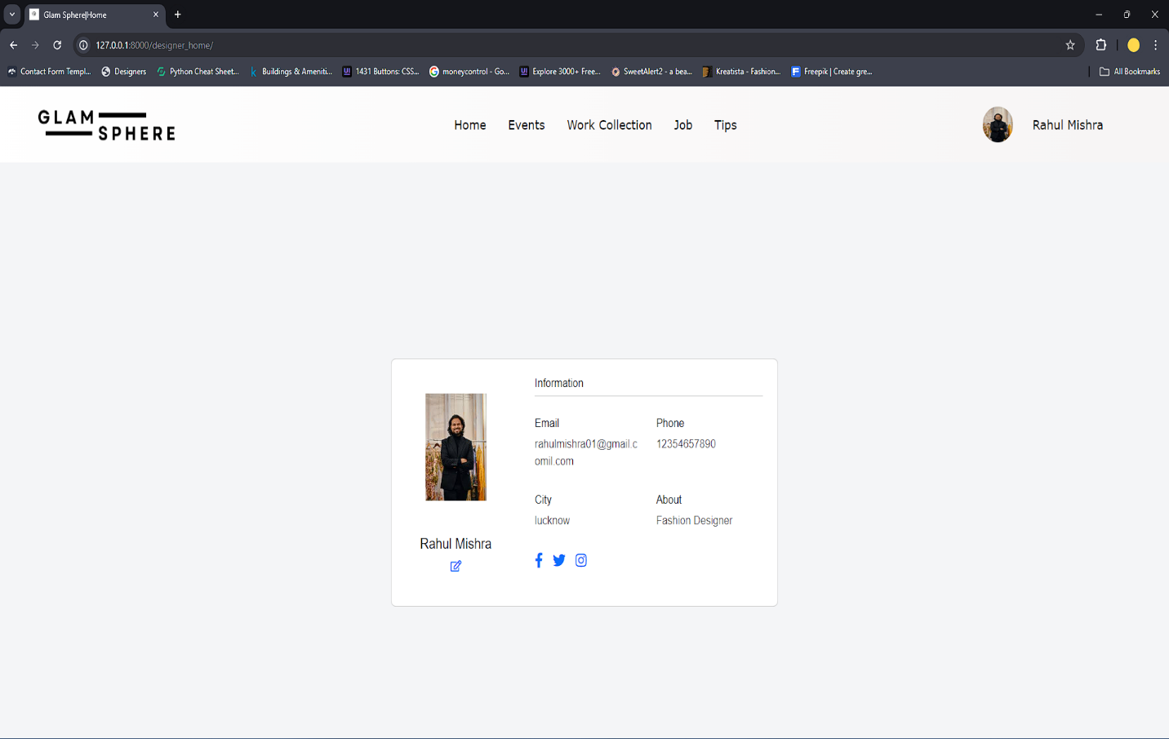

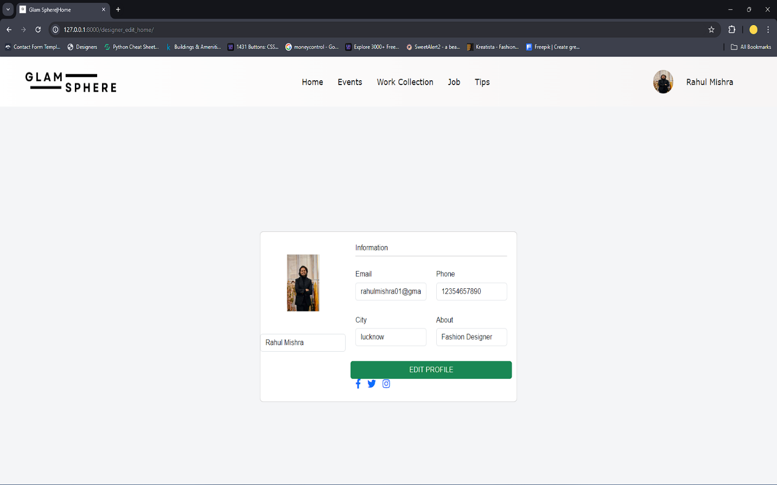

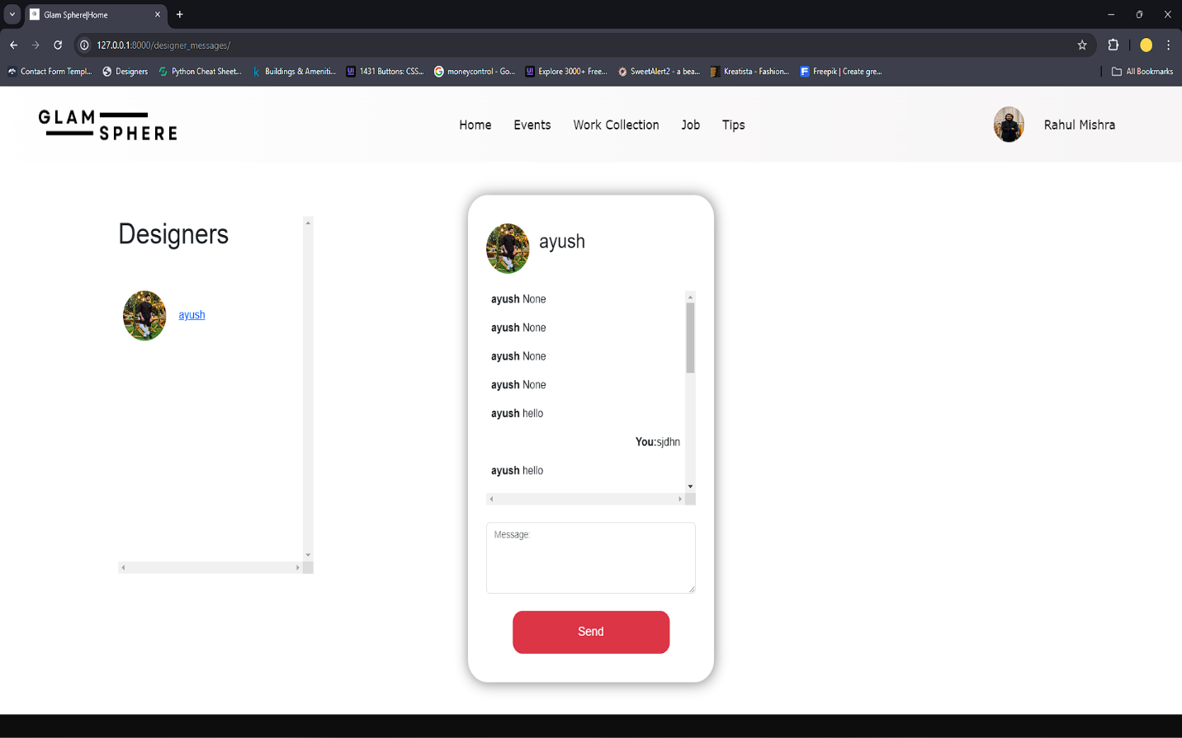

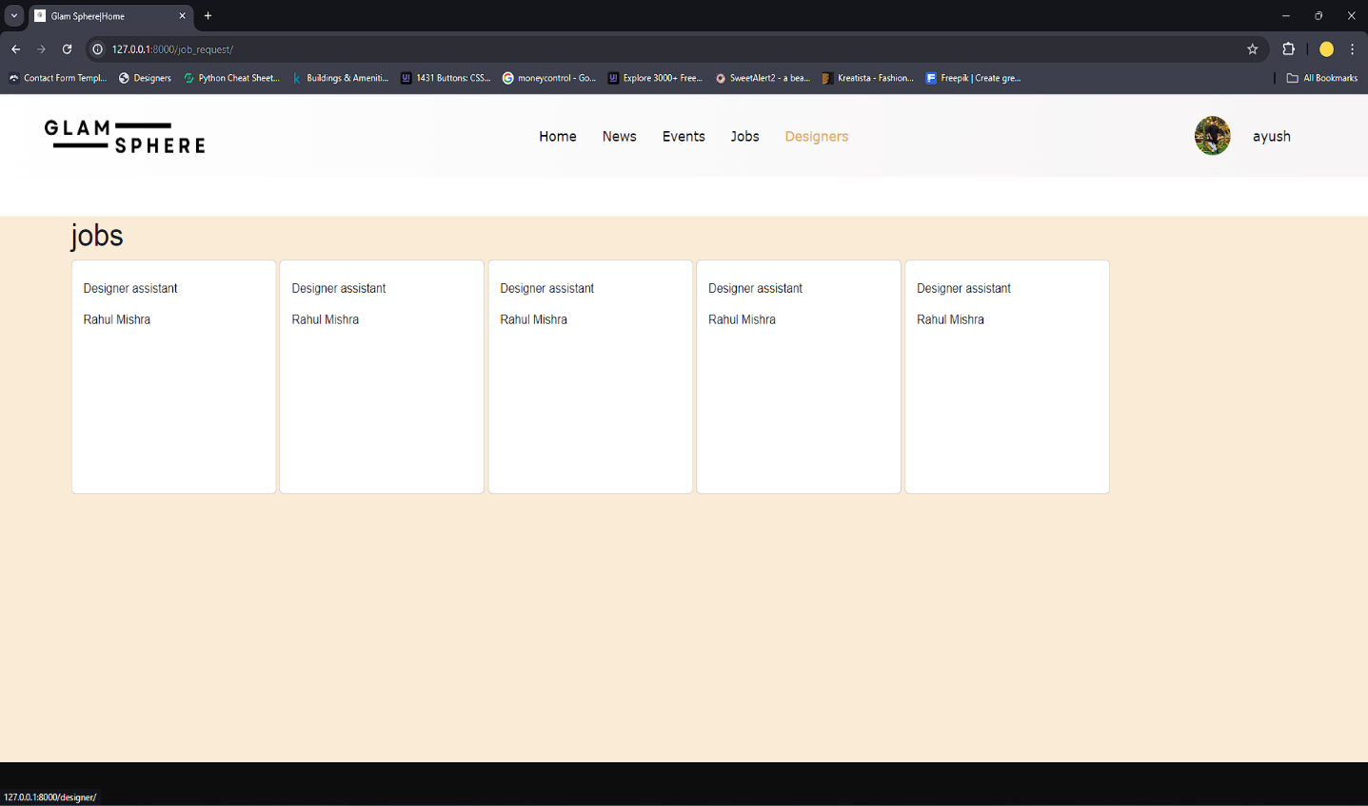

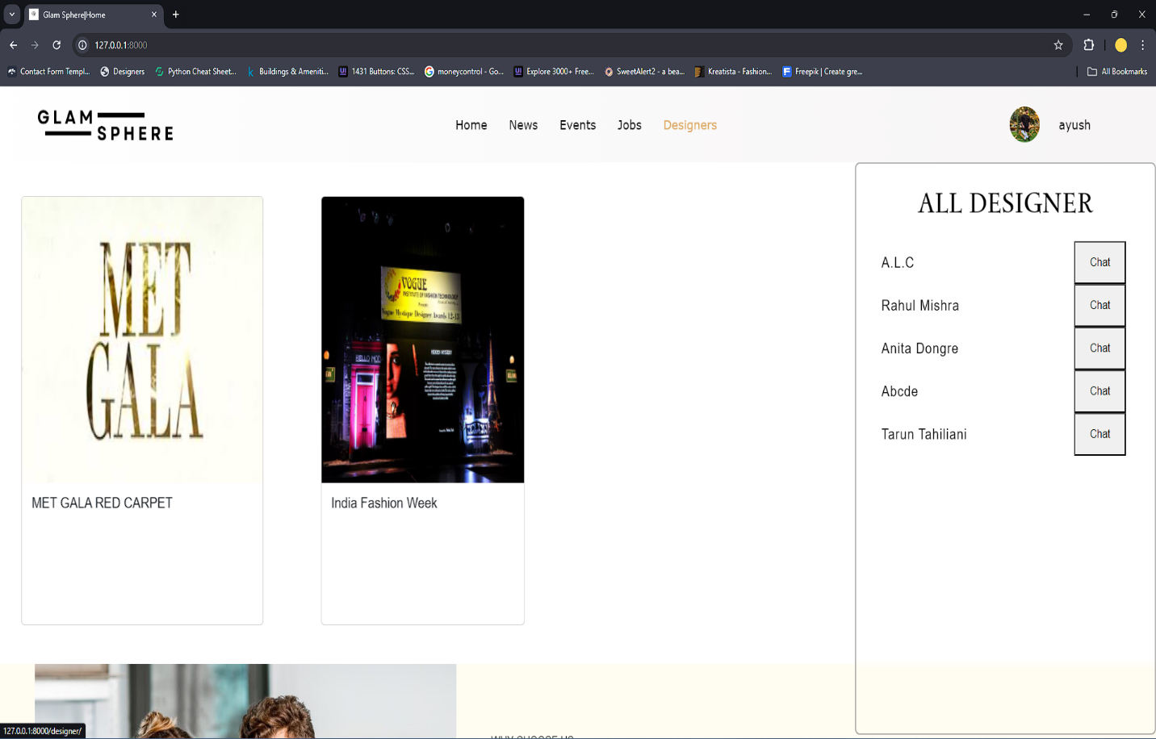

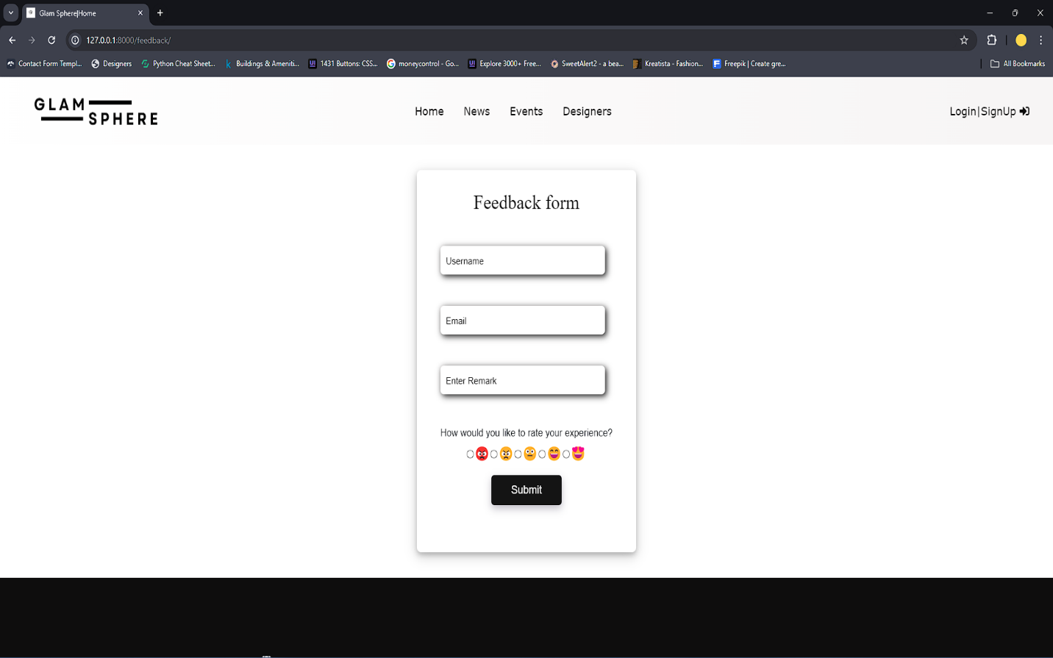

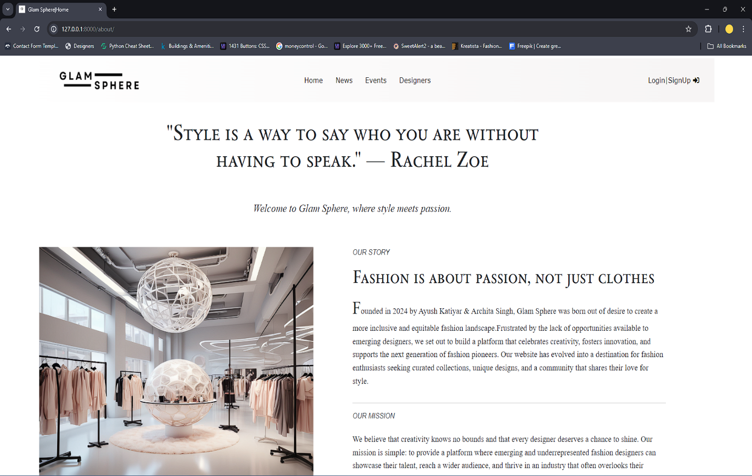

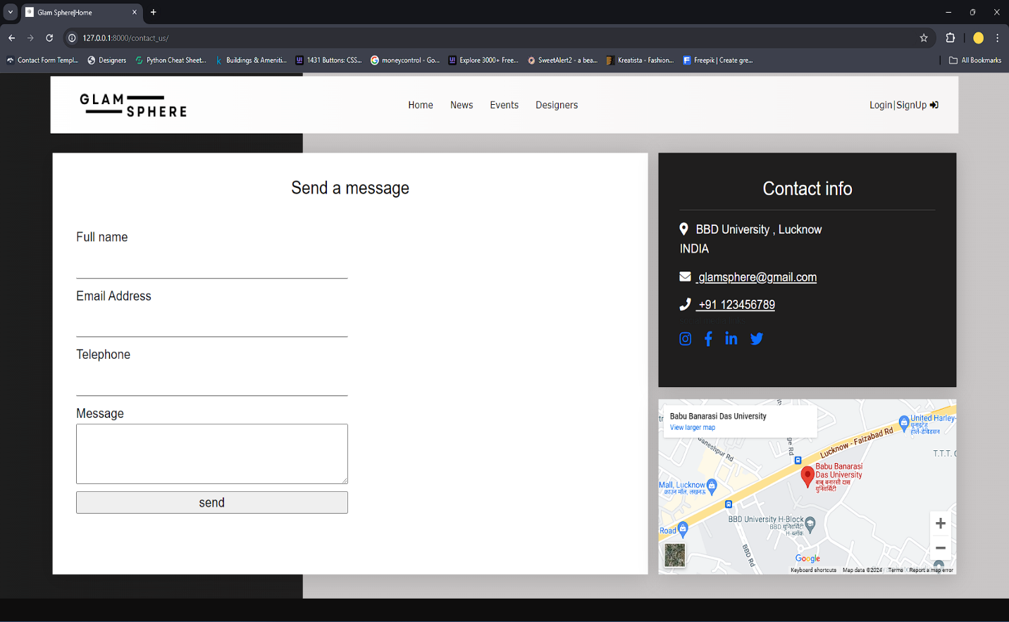

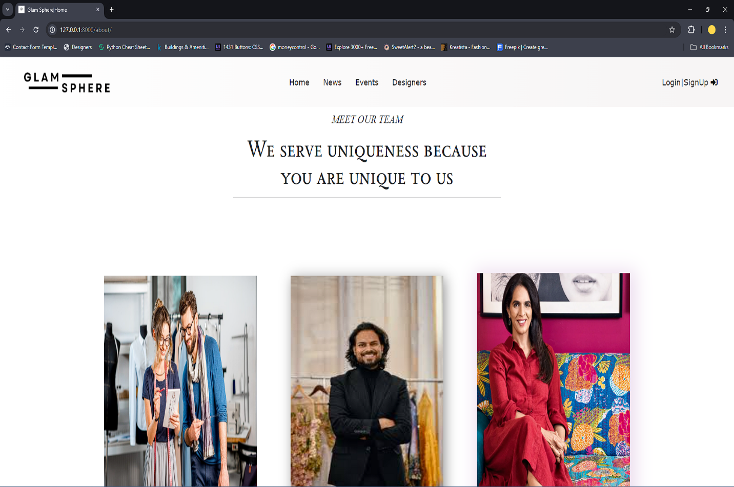

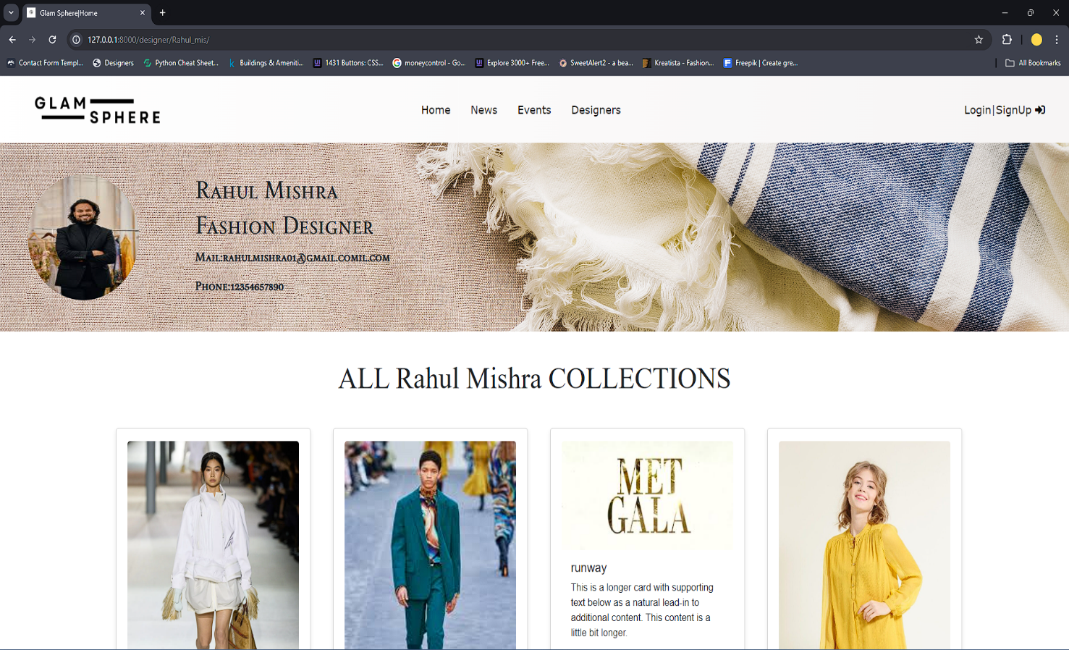

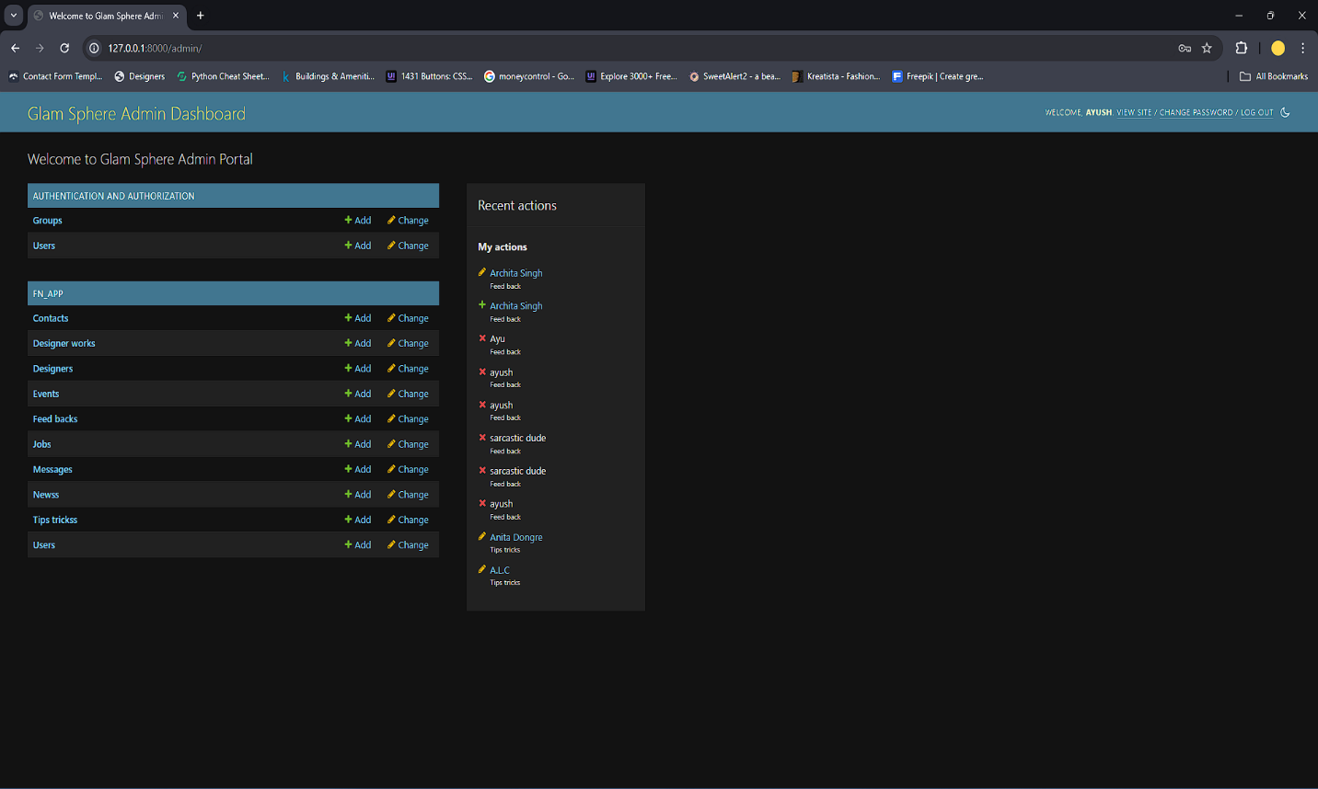

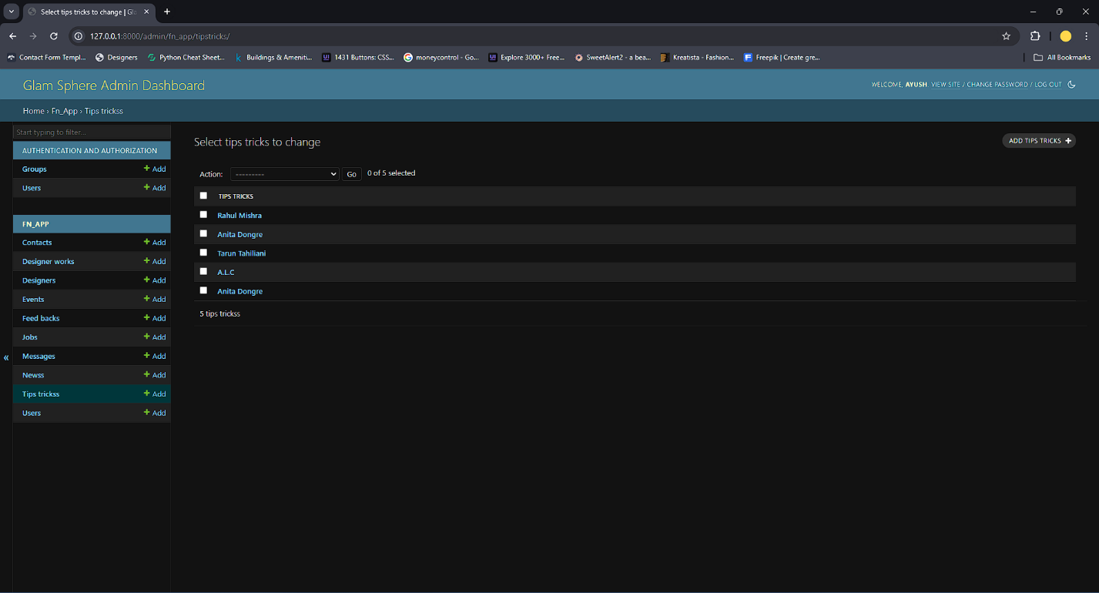

**TESTING**

***Testing Methodology:***

The modules are tested by the following testing methods

* Unit Testing
* Integration Testing
  1. ***Unit Testing:***

Unit testing is the process where you test the smallest functional unit of code. Software testing helps ensure code quality, and it's an integral part of software development. It's a software development best practice to write software as small, functional units then write a unit test for each code unit. We can first write unit tests as code. Then, run that test code automatically every time we make changes in the software code. This way, if a test fails, we can quickly isolate the area of the code that has the bug or error. Unit testing enforces modular thinking paradigms and improves test coverage and quality. Automated unit testing helps ensure you or your developers have more time to concentrate on coding.

* 1. ***Integration Testing:***

Integration testing is a type of software testing where components of the software are gradually integrated and then tested as a unified group. Usually, these components are already working well individually, but they may break when integrated with other components. With integration testing, testers want to find defects that surface due to code conflicts between software modules when they are integrated with each other.

Conflicts between software modules happen for many reasons, such as incompatibility between subsystem versions, data format conflict, or different processing logic. Integration testing pinpoints those communication issues between software components. It usually occurs after [unit testing](https://katalon.com/resources-center/blog/unit-testing) and before system testing.

* 1. ***Alpha Testing:***

Alpha testing is the first end-to-end testing of a product to ensure it meets the business requirements and functions correctly. It is typically performed by internal employees and conducted in a lab/stage environment. An alpha test ensures the product really works and does everything it’s supposed to do. Alpha tests can also be conducted using both “white box” and “black box” methods. In a white box setting, testers can “look inside” the product

to see what’s happening during the testing, which is typically not possible in a production setting, while a black box test simply provides the inputs and confirms the outputs are returned as expected.

* 1. ***Beta Testing****:*

Beta testing is an opportunity for real users to use a product in a production environment to uncover any bugs or issues before a general release. It is the final round of testing before releasing a product to a wide audience. The objective is to uncover as many bugs or usability issues as possible in this controlled setting.

Beta testers are “real” users and conduct their testing in a production environment running on the same hardware, networks, etc., as the final release. This also means it’s the first chance for full security and reliability testing because those tests can’t be conducted in a lab or stage environment.

Beta tests can either be open or closed. In an open test, anyone can use the product and is usually presented with some messaging that the product is in beta and given a method for submitting feedback. In closed beta, the testing is limited to a specific set of testers, which may be composed of current customers, early adopters, and/or paid beta testers. Sometimes they are conducted by diverting a certain percentage of users to the beta site instead of the current release.

1. ***TEST CASES:***

**Test ID: 1001 Test Date: 19/04/2024**

**Purpose: Testing of unit ‘LOGIN’**

|  |  |  |  |  |  |
| --- | --- | --- | --- | --- | --- |
| **b** | **Function/Procedure** | **Parameter Values** | **Expected Result** | **Actual Result** | **Result** |
| T001 | Login | User Id= “arc”  Password=arc | Invalid User id /  password | Invalid User id/  password | Pass |
| T002 | Login | User Id= “k101”  Password=khushi | Home Page Open | Home Page Open | Pass |
| T003 | Login | User Id= “arc510”  Password=arch | Invalid user Id or Password. | Invalid user Id or Password. | Pass |
| T004 | Login | User Id=Null  Password=Null | User Id and Password required | User Id and Password required | Pass |
| T005 | CheckID() | User Id= arc0510  Test Id= arc0510 | User already exists | User already exists | Pass |

Table 2. Test cases report

**CONSTRUCTIVE COST ESTIMATION MODEL (COCOMO)**

The COCOMO (Constructive Cost Model) is a widely used software cost estimation model developed by Barry Boehm in the late 1970s. It provides a structured approach for estimating the effort, time, and cost required to develop a software project based on various project parameters.

The COCOMO model is based on the premise that the effort required to develop software is proportional to the size of the project and influenced by other factors such as project complexity, development environment, and team experience. It offers different variants to accommodate projects of varying sizes and complexities:

1. Basic COCOMO (COCOMO 81): This variant is suitable for estimating the effort and cost of small to medium-sized projects. It uses a simple formula to estimate effort based on project size, measured in lines of code (LOC), and adjusts the effort estimate based on various project factors.

The formula for estimating effort in the basic COCOMO model is:

*E= a* x (KLOC)b

Where:

* *E* is the effort required to complete the project (in person-months).
* KLOC is the estimated size of the project in thousands of lines of code.
* *a* and *b* are constants that depend on the type of project being developed.

|  |  |  |  |
| --- | --- | --- | --- |
| **Project Type** | **a** | **b** |  |
| **Organic** | 2.4 | 1.05 |  |
| **Semi-detached** | 3.0 | 1.12 |  |
| **Embedded** | 3.6 | 1.20 |  |

1. Intermediate COCOMO (COCOMO II): This variant extends the capabilities of the basic COCOMO model to include additional factors that influence project effort and cost. It considers factors such as modern development practices, reuse of existing components, and distributed development teams.
2. Detailed COCOMO: This variant provides a more detailed and comprehensive estimation approach. It considers a wide range of project factors, including software reliability requirements, development schedule constraints, and the complexity of the development environment. Detailed COCOMO is suitable for large and complex projects where a high degree of accuracy is required.

The COCOMO model uses mathematical formulas and historical data from past software projects to estimate effort, time, and cost. It helps project managers and stakeholders make informed decisions about resource allocation, budgeting, and scheduling by providing realistic estimates of project parameters.

Despite its widespread use and popularity, the COCOMO model has some limitations, such as its reliance on historical data, assumptions about project characteristics, and the need for expert judgment in interpreting estimation results. However, when used appropriately and in conjunction with other estimation techniques, COCOMO can be a valuable tool for software project management and planning.

**LIMITATION AND FUTURE SCOPE**

Fashion websites heavily rely on high-quality imagery and visual content, which can pose challenges in terms of photography, graphic design, and content creation. Maintaining a consistent supply of fresh and appealing visuals may be resource-intensive and time-consuming. Also, implementing advanced personalization techniques, such as AI-driven recommendations, requires sophisticated algorithms and technical expertise. Integrating these features seamlessly into the website's architecture may be complex and costly. The fashion industry is highly competitive, with numerous fashion designer websites vying for attention. Standing out from the competition and attracting and retaining users may be challenging in such a crowded marketplace.

We aim at continuously improving and refining AI-driven recommendation algorithms to provide users with highly personalized shopping experiences tailored to their preferences and behaviour. Implementing AR technology to allow users to virtually try on clothing items and accessories, providing a more immersive and interactive shopping experience. Encouraging users to contribute their own content, such as reviews, photos, and styling tips, to foster a sense of community and engagement on the website. Incorporating features that highlight sustainable fashion practices and eco-friendly products, catering to the growing demand for ethically produced and environmentally conscious fashion. Expanding the reach of the website to new markets and regions, either through localization efforts or partnerships with international designers and brands, to attract a broader audience and increase sales potential.

**CONCLUSION**

In summary, the significance of a fashion designer portal cannot be overstated, as it offers designers an invaluable platform to not only exhibit their artistic ingenuity but also to forge meaningful connections with clients and solidify their brand presence amidst the cutthroat milieu of the fashion realm. By embracing traits of innovation, adaptability, and unwavering dedication to customer satisfaction, such portals are poised to not just survive but thrive in the ever-evolving landscape of the industry. Through strategic navigation of industry intricacies and a steadfast commitment to customer-centric approaches, these portals have the potential to not only drive heightened engagement and sales but also to emerge as influential trailblazers shaping the future of fashion.

**BIBLIOGRAPHY**

**Books**

William S. Vincent (2018). Django For Beginners: Build websites with Python & Django.

**Websites**

<https://www.asos.com/>

<https://thefashionhub.co/>

<https://www.vogue.in/>

<https://www.thefashionspot.com/>

<https://www.fashionbeans.com/>

<https://preview.themeforest.net/item/kreatista-fashion-designer-elementor-template-kit/full_screen_preview/50071124?_ga=2.179161895.2000767961.1715163330-898742568.1715163330>

**Other**

1. Canva app―Logo and Monogram designing
2. Unsplash, Pixabay, Freepik― For static images
3. Draw.io―Creating models